Family and Friends email from September 5, 2008
-------Original Message-------

From: Katie Troccoli, Wash Square
Date: 9/19/2008 4:26:46 PM
To: Family & Friends 505 RCT
Subject: Artist for paintings

Hi All,
I looked at the prints that I bought at All American Week at Fort Bragg this spring. They are of Afghanistan. The artists name is Fred Rothenbush of Ruskin Florida. I will look for his contact information as I think I have a business card at home if I can find it. If you Google his name there is a lot of information out there about him.
Katie

-------Original Message-------

From: David.V
Date: 9/29/2008 1:02:48 PM
Subject: OMAHA BEACH...

Hi all !!!!
Some pictures that a friend of mine took yesterday....
Each year, at the end of September and at the begining of June....the sand on Omaha Beach "Cry" blood.....at the same place, in front the WN 62, one of the most deadly place on June 6 1944.....
We doesn't know why....
A special mail for Mr GROSSMAN David....
Take care, from Normandie : David, Sabine and Léa.
(Jenny, you will recognize Joel !!!!)

-------Message original-------

De : Marie-Helene GANDIN
Date : 28/09/2008 20:09:27
A : David.V; lesueur.jean-marc
Sujet : c'est joel

chaque année vers le 6 juin et au mois de septembre un liquide couleur de sabng sort de la plage d omahah toujors au meme endroit face le wn 62 la ou sont mort environ 1200 soldats us, voici des photsos de cette année surprenant non ???

- Attachment 1: Voyage Normandie sept 2008 269.jpg (image/jpeg)
Attachment 3: P1010029.JPG (image/jpeg)

-------Original Message-------

From: Bob Murphy
Date: 9/29/2008 2:04:27 PM

Hi everyone,
This is Bob Murphy's daughter, Christina, letting everyone know that my dad has been transferred to Cape Regency Nursing Home in Centerville, MA. He is now on oxygen, and it is difficult for him to speak. This is due to the pneumonia. He will be receiving physical therapy as well as nursing care. I am unsure whether, or not he will be returning to his home. I will do my best to keep everyone up to date on his condition. I have told him daily that people have called me, and have him in their prayers. Please call me, or leave a message on my email. , . He is blessed to have so many people in his life that love him. You are all his family.
Sincerely, Christina Murphy
Bob Murphy
Dear Friends,

I am sad to report that Bob's condition is worsening. Since he went back in the hospital Tuesday his condition has deteriorated. I just spoke to Bob's daughter Christina tonight and she told me the doctors have told her there is no hope left for him to pull through this fight. Bob told Christina that he didn't want any more efforts made to save him. She has read all the letters and cards and told him of the phone calls from his many friends in the Airborne Family and his many friends all over Europe that they were all praying for him. Bob asked Christina to thank everyone for their cards letters and prayers. His children and grandchildren are all there to comfort him. Christina said the doctors have put him on morphine this evening and have done all they could do to comfort him. It is so sad for me to be the one to tell you this as Bob has always been a true friend and has helped me in so many ways. I know everyone feels this way. Please keep him in your heart and prayers tonight as he fights his last battle on earth.

AIRBORNE ALL THE WAY

Jim Blankenship
Family & Friends 505RCT
From:
"Family & Friends 505 RCT" <
To:
"Family & Friends 505RCT Membership" <
Subject:
Bob Murphy
Date:
Friday, October 03, 2008 1:58:18 PM
Friends:

Many of you know of Bob Murphy's critical condition and his fight with cancer. I talked to his daughter Christina last night and his condition is worse. The doctors have put him on morphine and said it near the end. Please remember Bob in your prayers and also his family that are with him in his final hours.
I will keep everyone informed as to his condition.

I have included a picture of Bob with Gen. David Petraeus made this past April at the Static Line awards in Atlanta.

AIRBORNE ALL THE WAY

Jim Blankenship
Family & Friends 505RCT

- Attachment 1: 102 - Bob Murphy and Gen. Petraeus.jpg (image/jpeg)

From:
"Family & Friends 505 RCT" <
To:
"Family & Friends 505RCT Membership" <
Subject:
Bob Murphy Passes
Date:
Friday, October 03, 2008 6:18:31 PM
Subject: Bob Murphy Passes

Bob Murphy made his final jump at 5:25 this afternoon in Hyannis Port, MA. His daughter Christina said he died peacefully with his family at his bedside.
We have all lost a great friend and a true Airborne Paratrooper. We will always remember him with his big smile and friendly ways. I will keep you informed as to funeral plans.

AIRBORNE ALL THE WAY

Jim Blankenship
Family & Friends 505RCT

-------Original Message-------

From: hjyv.renaud
Date: 10/3/2008 12:54:04 PM
To: family & friends
Subject: Bob

Dear friends I don't speak enough well to tell how deep is my sadness. I know Bob since 1964 when he came back to jump again on Sainte Mère Eglise with his friend John Lee. The D-Day anniversary will never be the same for me and for the French citizens of my town.On the attachment is a picture taken in June 2007 in my home as Bob asked me to organize a special Kids party for him, and we did it again last June 2008. It was only 3 months ago...... I hope that my grandchildren will remember. Henri Jean Renaud

-------Original Message-------

From: barbara sherer
Date: 10/3/2008 11:20:05 PM
To: Family & Friends 505 RCT
Subject: Re: Fw: Bob

Dear All,

I can't express how sad I am at hearing about Bob's death. Next to my dad (Doc Franco), Bob was one of THE best. There will be a enormous void where Bob used to hold court. He will be sorely missed.

Always, Barbara (Franco) Sherer

--- On Fri, 10/3/08, Family & Friends 505 RCT <

> From: Family & Friends 505 RCT <
> Subject: Fw: Bob
> To: "Family & Friends 505RCT Membership" <
> Date: Friday, October 3, 2008, 6:22 PM
> -------Original Message-------
>
> From: hjyv.renaud
> Date: 10/3/2008 12:54:04 PM
> To: family & friends
> Subject: Bob
>
> Dear friends I don't speak enough well to tell how deep
> is my sadness. I
> know Bob since 1964 when he came back to jump again on
> Sainte Mère Eglise
> with his friend John Lee. The D-Day anniversary will never
> be the same for
> me and for the French citizens of my town.On the attachment
> is a picture
> taken in June 2007 in my home as Bob asked me to organize a
> special Kids
> party for him, and we did it again last June 2008. It was
> only 3 months ago.
> .... I hope that my grandchildren will remember.
> Henri Jean Renaud

From:
"Family & Friends 505 RCT" <f
To:
"Family & Friends 505RCT Membership" <
Subject:
Funeral Arrangements
Date:
Friday, October 03, 2008 9:03:54 PM
I will be out of town for the next four days on business. Our secretary/treasurer Ellen Peters will be on hand to answer any questions you may have.
Information is as follows...
Sympathy cards may be sent to ...........

Robert M. Murphy Family

Ellen Peters, Secretary-Treasurer:
Family & Friends 505RCT

AIRBORNE ALL THE WAY

Jim Blankenship
Family & Friends 505RCT

-------Original Message-------

From: Frits Janssen
Date: 10/4/2008 6:10:39 AM
To: Family & Friends 505 RCT
Subject: My good friend Bob.

My good friend Bob

Today my good friend Robert(Bob) M Murphy passed away. Our friendship started back in 1995 when Joe Meyers introduced us to each other. When Bob sent me the manuscript of his book with the question to check on mistakes, I gave him my first phonecall. I can remember it like it was yesterday. I never expected to find such a friendly and warm personality like he was. I spoke to him on the phone for over 2 hours and we had some good laughs. Because I am living in The Netherlands we talked most over his service during Operation Market-Garden. When he heard that I was moving to Mook, the place where he had some pretty bad days in WWII, he was very enthousiastic. From that moment we start seeing eachother more often and our friendship was growing.

In 2003 I started the Remember September 1944 Foundation. Bob helped me a lot. Not just with information but he also provided me with pictures, copies of records, after-action reports etc. But most important was his support and thankness that kept me going. As an extra support he gave me his paybook and WWII shirt. These items already had a special place in my exhibition but from now on also stands for the loss of one of the greatest persons and truly friend I know.

The last few years I was kind of his peronal driver. When he came over to Europe, he called me and asked me to pick him up and drive him around.

June 2008 was the last time. He knew by that time that he had cancer and that he had to fight a battle which was almost impossible to win. But he had the spirit to fight and besides that, still found the time to talk to and see all his friends in Normandy. We stayed in one room at his favorite place in Normandy, La Fiere Manoir, and we had some long talks.

I will cherish all the moments, good times and laughs we had together. It is good to know that he now is with his many friends he lost along the way.

Bob, I love you and I will never forget you.

My thoughts are with his family and all his good friends.

Your good friend Frits.

-------Original Message-------

From: Emile Lacroix
Date: 10/4/2008 4:09:09 AM
To: MURPHY Christina
Cc: FAMILY and FRIENDS 505RCT
Subject: Fw: Fw: Bob's Condition

Christina,
Here are some other reactions about Bob which came to me after forwarding the sad news about him to some friends.
Bob was loved by everyone.
Emile

----- Original Message -----
From:
Sent: Saturday, October 04, 2008 12:39 AM
Subject: Re: Fw: Bob's Condition

Emile,

I think that all of us have the same feeling in our hearts for a great friend. He will be missed by everyone that ever got a chance to know him. But one good thing. He will never be forgotten in the history books. It's been a privilege and an honor to have known one of the most famous pathfinders that ever put on a pair of jump boots. What an incredible individual. And to stick out in the ranks of one of the best branches of the military. Field Marshal Montgomery said something about paratroopers. They were not just an individual soldier, each man was an emperor. And they would continue with their missions no matter what the odds were. Bob Murphy I would say was a standout type of guy, even in that group. He told me the story about how he was promoted in the Reserves to "Full-Bird Colonel" after my friend, Bill Outten (501) was pushing him for some stories at the 82nd mini reunion in Arlington a few years ago. Bob had gotten wounded near Montebourg in Normandy and had just gotten out of the hospital back in England. He asked for some "off time" and the Lt. told him that "no", no passes were being allowed as they might have another mission in the near future. Bob continued to beg for a pass and the Lt. finally said, "I'LL let you go, but I know nothing of it if we get called out". Well, they got called out and Pvt. Murphy missed formation. When he got back, he loaded up on the C-47 to go to Holland on the morning of 17 September 1944. Some officer came to the door of the aircraft and asked if their was a Pvt. Robert M. Murphy on the aircraft? Well, here's a group of fully loaded paratroopers with live ammo, grenades and all the rest of the tools of trade. They asked why Murphy was supposed to get off the aircraft, "as this officer ordered"? When he said Murphy was up on charges of being AWOL, the guys responded with: "Murphy's here, but he's not going anywhere but Holland". I guess this officer finally figured that these guys meant what they said. He left the aircraft and went on his business. Well, years later, JAG Lawyer LT. Col. Murphy got promoted to "Full-Colonel". He was on active duty for his two weeks and in the Pentagon walking down one of the halls when he was stopped by a general officer. He looked around as he was being passed by the General. He said, "Murphy, did you recently get that eagle on your shoulder"? Bob happily answered "yes". And the officer then asked, "do you know why you got it"? Murphy responded, "I guess my record was better then some of the others". At that point the General laughed and said, "no, you got it for being AWOL". And he told him how someone on the board saw the story in Bob's records and said, "listen to this"!!!! And it was almost unanimous. They decided that this guy had a chance of getting out of parachuting into combat (his 3rd time) and turned it down. Yes, he turned down a free pass, an easy way out. But Bob Murphy wouldn't leave his buddies. That's the kind of guy Bob Murphy was, and still is!

Ste Mere Eglise will not be the same without having Bob in the crowd. He will be missed by all of us. But then again, we will see him later at "The final drop zone". I sure hope that they have a place big enough for all of us to hang out!

Emile, that photo you took of Bob with Bill Sullivan in June, which is on my website. The pair of them standing in Ste. Mere Eglise on 6 June this year. I think that photo is worth a $Million bucks!!!! Thanks again for catching a moment of one of the greatest guys that ever wore a pair of jump boots.

Tim Roop
All The Way!

In a message dated 10/3/2008 5:42:03 P.M. Eastern Daylight Time, writes:

----- Original Message -----
From: Emile Lacroix
To: Family & Friends 505 RCT
Cc: MURPHY Christina
Sent: Friday, October 03, 2008 12:31 PM
Subject: Re: Bob's Condition

Jim,
It's so sad to hear that and I am so deeply sorry for my very good friend Bob who will go that way. he was still so joyous last February when he came to our 82nd Airborne march stayed at my home and met all those children in Wasseige school where he was so well welcomed and made a conference there. He loved so much children.
Then last June in Normandy all had changed. He was still suffering but tried to not show it. When he left Normandy and said good bye to all of us, his friends there, we knew we had few chances to see him again but wanted to hope in spite of all. It's hard to thing of this and being so far from a friend suffering his last moments without to be able to comfort him.
If you had the occasion, please tell Bob that Emile, his Belgian friend and his family will never forget him (specially his kids).
Emile Lacroix and family.

---- Original Message -----
From: Family & Friends 505 RCT
To:
Sent: Friday, October 03, 2008 4:07 AM
Subject: Bob's Condition

Dear Friends,

I am sad to report that Bob's condition is worsening. Since he went back in the hospital Tuesday his condition has deteriorated. I just spoke to Bob's daughter Christina tonight and she told me the doctors have told her there is no hope left for him to pull through this fight. Bob told Christina that he didn't want any more efforts made to save him. She has read all the letters and cards and told him of the phone calls from his many friends in the Airborne Family and his many friends all over Europe that they were all praying for him. Bob asked Christina to thank everyone for their cards letters and prayers. His children and grandchildren are all there to comfort him. Christina said the doctors have put him on morphine this evening and have done all they could do to comfort him. It is so sad for me to be the one to tell you this as Bob has always been a true friend and has helped me in so many ways. I know everyone feels this way. Please keep him in your heart and prayers tonight as he fights his last battle on earth.

AIRBORNE ALL THE WAY

Jim Blankenship
Family & Friends 505RCT

-------Original Message-------

From: Troop
Date: 10/4/2008 1:47:46 AM
To: ff
Subject: Re: Bob

Hey Henri Jean,

What a great photograph. I hope you can post it in the musée a Troupes des Aeroportées, Bob was a great guy!

Tim Roop
www.ww2dday.com

In a message dated 10/3/2008 9:32:24 P.M. Eastern Daylight Time, writes:
-------Original Message-------

From: hjyv.renaud
Date: 10/3/2008 12:54:04 PM
To: family & friends
Subject: Bob

Dear friends I don't speak enough well to tell how deep is my sadness. I know Bob since 1964 when he came back to jump again on Sainte Mère Eglise with his friend John Lee. The D-Day anniversary will never be the same for me and for the French citizens of my town.On the attachment is a picture taken in June 2007 in my home as Bob asked me to organize a special Kids party for him, and we did it again last June 2008. It was only 3 months ago...... I hope that my grandchildren will remember. Henri Jean Renaud

From:
"Family & Friends 505 RCT" <
To:
"Family & Friends 505RCT Membership" <
Subject:
Bob Murphy
Date:
Thursday, September 25, 2008 4:30:53 PM
I spoke with Bob earlier this evening and he is in the hospital. He asked me to let everyone know and please do not send any emails. His condition is very serious and I would like to ask everyone to keep him in your prayers. I will keep everyone informed of his condition.

AIRBORNE ALL THE WAY

Jim Blankenship
Family & Friends 505RCT

From:
"Family & Friends 505 RCT" <f
To:
"Family & Friends 505RCT Membership" <
Subject:
update on Bob Murphy
Date:
Friday, September 26, 2008 9:33:28 PM
I spoke with Bob this evening and he seems to be improving over his condition yesterday. If all goes well he expects to be released from the hospital in a few days. He asked me to thank everyone for their support and prayers. I told him his many friends all wish him well.
AIRBORNE ALL THE WAY

Jim Blankenship
Family & Friends 505RCT

From:
"Family & Friends 505 RCT" <f
To:
"Family & Friends 505RCT Membership" <
Subject:
Bob's Condition
Date:
Saturday, October 04, 2008 4:17:02 AM
-------Original Message-------

From: Emile Lacroix
Date: 10/4/2008 4:09:09 AM
To: MURPHY Christina
Cc: FAMILY and FRIENDS 505RCT
Subject: Fw: Fw: Bob's Condition

Christina,
Here are some other reactions about Bob which came to me after forwarding the sad news about him to some friends.
Bob was loved by everyone.
Emile

----- Original Message -----
From:
Sent: Saturday, October 04, 2008 12:39 AM
Subject: Re: Fw: Bob's Condition

Emile,

I think that all of us have the same feeling in our hearts for a great friend. He will be missed by everyone that ever got a chance to know him. But one good thing. He will never be forgotten in the history books. It's been a privilege and an honor to have known one of the most famous pathfinders that ever put on a pair of jump boots. What an incredible individual. And to stick out in the ranks of one of the best branches of the military. Field Marshal Montgomery said something about paratroopers. They were not just an individual soldier, each man was an emperor. And they would continue with their missions no matter what the odds were. Bob Murphy I would say was a standout type of guy, even in that group. He told me the story about how he was promoted in the Reserves to "Full-Bird Colonel" after my friend, Bill Outten (501) was pushing him for some stories at the 82nd mini reunion in Arlington a few years ago. Bob had gotten wounded near Montebourg in Normandy and had just gotten out of the hospital back in England. He asked for some "off time" and the Lt. told him that "no", no passes were being allowed as they might have another mission in the near future. Bob continued to beg for a pass and the Lt. finally said, "I'LL let you go, but I know nothing of it if we get called out". Well, they got called out and Pvt. Murphy missed formation. When he got back, he loaded up on the C-47 to go to Holland on the morning of 17 September 1944. Some officer came to the door of the aircraft and asked if their was a Pvt. Robert M. Murphy on the aircraft? Well, here's a group of fully loaded paratroopers with live ammo, grenades and all the rest of the tools of trade. They asked why Murphy was supposed to get off the aircraft, "as this officer ordered"? When he said Murphy was up on charges of being AWOL, the guys responded with: "Murphy's here, but he's not going anywhere but Holland". I guess this officer finally figured that these guys meant what they said. He left the aircraft and went on his business. Well, years later, JAG Lawyer LT. Col. Murphy got promoted to "Full-Colonel". He was on active duty for his two weeks and in the Pentagon walking down one of the halls when he was stopped by a general officer. He looked around as he was being passed by the General. He said, "Murphy, did you recently get that eagle on your shoulder"? Bob happily answered "yes". And the officer then asked, "do you know why you got it"? Murphy responded, "I guess my record was better then some of the others". At that point the General laughed and said, "no, you got it for being AWOL". And he told him how someone on the board saw the story in Bob's records and said, "listen to this"!!!! And it was almost unanimous. They decided that this guy had a chance of getting out of parachuting into combat (his 3rd time) and turned it down. Yes, he turned down a free pass, an easy way out. But Bob Murphy wouldn't leave his buddies. That's the kind of guy Bob Murphy was, and still is!

Ste Mere Eglise will not be the same without having Bob in the crowd. He will be missed by all of us. But then again, we will see him later at "The final drop zone". I sure hope that they have a place big enough for all of us to hang out!

Emile, that photo you took of Bob with Bill Sullivan in June, which is on my website. The pair of them standing in Ste. Mere Eglise on 6 June this year. I think that photo is worth a $Million bucks!!!! Thanks again for catching a moment of one of the greatest guys that ever wore a pair of jump boots.

Tim Roop
All The Way!

In a message dated 10/3/2008 5:42:03 P.M. Eastern Daylight Time, emile writes:

----- Original Message -----
From: Emile Lacroix
To: Family & Friends 505 RCT
Cc: MURPHY Christina
Sent: Friday, October 03, 2008 12:31 PM
Subject: Re: Bob's Condition

Jim,
It's so sad to hear that and I am so deeply sorry for my very good friend Bob who will go that way. he was still so joyous last February when he came to our 82nd Airborne march stayed at my home and met all those children in Wasseige school where he was so well welcomed and made a conference there. He loved so much children.
Then last June in Normandy all had changed. He was still suffering but tried to not show it. When he left Normandy and said good bye to all of us, his friends there, we knew we had few chances to see him again but wanted to hope in spite of all. It's hard to thing of this and being so far from a friend suffering his last moments without to be able to comfort him.
If you had the occasion, please tell Bob that Emile, his Belgian friend and his family will never forget him (specially his kids).
Emile Lacroix and family.

---- Original Message -----
From: Family & Friends 505 RCT
To: Barbara Gavin Fauntleroy; Bob Burns; Ellen Peters; Jim Blankenship ; Genegarren; Joseph Schwan - 505th Prcht Inf; Katie Troccoli; Ray Fary
Cc: Deryk Wills; Emile Lacroix; Henri-jean Renaud; David Wills; Jan Bos
Sent: Friday, October 03, 2008 4:07 AM
Subject: Bob's Condition

Dear Friends,

I am sad to report that Bob's condition is worsening. Since he went back in the hospital Tuesday his condition has deteriorated. I just spoke to Bob's daughter Christina tonight and she told me the doctors have told her there is no hope left for him to pull through this fight. Bob told Christina that he didn't want any more efforts made to save him. She has read all the letters and cards and told him of the phone calls from his many friends in the Airborne Family and his many friends all over Europe that they were all praying for him. Bob asked Christina to thank everyone for their cards letters and prayers. His children and grandchildren are all there to comfort him. Christina said the doctors have put him on morphine this evening and have done all they could do to comfort him. It is so sad for me to be the one to tell you this as Bob has always been a true friend and has helped me in so many ways. I know everyone feels this way. Please keep him in your heart and prayers tonight as he fights his last battle on earth.

AIRBORNE ALL THE WAY

Jim Blankenship
Family & Friends 505RCT

From:
"Family & Friends 505 RCT" <
To:
"Family & Friends 505RCT Membership" <
Subject:
Fw: Re: Bob Murphy Passes
Date:
Tuesday, October 07, 2008 6:57:31 PM
-------Original Message-------

From: ROBERT GILLETTE
Date: 10/6/2008 12:54:12 AM
To: Family & Friends 505 RCT
Subject: Re: Bob Murphy Passes

Dear all:

I first met Bob Murphy on my first return to Normandy in 1977. I had not known him during our times in WWII. Since 1977 he has been a good friend and most helpful to me.

I worked with him during the formative days of the 505RCT and would have liked to work more often with him but have been constrained in my activities by my wife's dementia. I join all others in the 505RCT and the Family and Friends brotherhood in expressing my admiration for all he has done.

In addition to his many friendships, Bob's continuing legacy is the vast amount of energy he invested in assuring that the 505, the 82nd and all Airborne will be remembered by many more than only family and friends. May he rest in peace. Bob Gillette

----- Original Message -----
From: Family & Friends 505 RCT
----- Original Message -----
From: Family & Friends 505 RCT
To: Family & Friends 505RCT Membership
Sent: Friday, October 03, 2008 6:18 PM
Subject: Bob Murphy Passes

Subject: Bob Murphy Passes

Bob Murphy made his final jump at 5:25 this afternoon in Hyannis Port, MA. His daughter Christina said he died peacefully with his family at his bedside.
We have all lost a great friend and a true Airborne Paratrooper. We will always remember him with his big smile and friendly ways. I will keep you informed as to funeral plans.

AIRBORNE ALL THE WAY

Jim Blankenship
Family & Friends 505RCT

From:
"Family & Friends 505 RCT"
To:
"Family & Friends 505RCT Membership" <
Subject:
Bob Murphy
Date:
Tuesday, October 07, 2008 8:34:13 PM
Date: Tuesday, October 7, 2008, 8:29 AM

Cannes France

When BOB told us last April that he had a cancer we feared he would not
make it for D Day 2008 in Sainte Mere
In spite of the pain he made a point to attend the ceremonies.One was the
magnificent celebration at MONT SAINT MICHEL where
BOB was honored with the medal of the French senate among hundreds of viewers
and a parade of US paratroopers.
As usual he was in great spirits and all smiles at his little kids party
which he was giving each year at my brother Henri Jean s house. We were all
happy to see him in such a good mood ,telling his usual jokes .We did hide our
sadness knowing that he would not be with us next year.

In Sainte Mere BOB was the mega star of the Airborne Veterans. Why is
that ?

IT all started in the late 60s when BOB showed up in Sainte Mere and inquired
with the possibility of making a commemorative jump on D Day with few other
Veterans..With the active help of my mother he obtained the necessary
authorizations and a plane.
When they jumped it became locally a sensational event.As the US medias
never report of what is going on in Sainte Mere you never heard about it at that
time in the States.
Few years later he joined with his good friend YVES TARIEL to organize
more structured D Day jumps in combination with French civilian and
paratroopers and the participation of the French Air Force.
BOB and YVES are the 2 individual who really did put the D Day jumps on
the map

BOB attended religiously every D Day ,he was very popular and always ready
to help.
BOB brought his full support to my mother s AVA,to YVES TARIEL S project
to bring ,single handedly,the C47 plane to the museum,to the IRON MIKE
monumument in La Fiere and to few other projects.

When I talked to him on Sept 21st he was in pain but in full control. He
became very animated when he mentioned the very unfriendly way in which the C47
Club was behaving towards his friend EMILE LACROIX in Belgium. He was also upset
to know that his film NO BETTER PLACE TO DIE was cancelled due to bad
management.

Colonel BOB PIPER, DON LASSEN and now BOB MURPHY all our heroes are
leaving us.

This is the end of an era.Sainte Mere will never be the same

History made you part of our lives You honored us with your friendship

May you rest in peace and in glory in this very special place in Heaven
reserved for the Airborne soldiers

Maurice RENAUD

____________________________________________________

Écoutez gratuitement Louisy Joseph sur Voila et découvrez d'autres titres
en affinité avec vos goûts musicaux ! http://musiline.voila.fr/resume/11777

AIRBORNE ALL THE WAY

Jim Blankenship
Family & Friends 505RCT

-------Original Message-------

From: Claude Timmermans
Date: 10/5/2008 8:01:42 AM
To:
Subject: BOB MURPHY

It is with great emotion that I read yesterday that Mr Bob Murphy passed away.
I sent my tribute to all his family.
Once again a great man is gone, have a thought of every day for him
Claude Timmermans
------Original Message-------

From: Ellen Peters
Date: 10/7/2008 10:15:27 PM
To: Family and Friends of the 505th RCT; Jim Blankenship
Subject: Fw: Re: Re: Bob's Friends

I received the below from Emile.

E
--- On Mon, 10/6/08, Emile Lacroix < > wrote:
From: Emile Lacroix <
Subject: Re: Re: Bob's Friends
Ellen,
Bob was so loved by children. You remember when you were at my home with Bob last February with Bob. My grand children who were there, Frank, Marvin Manon and Ethan were always around him and he was always playing with them. They called him Uncle Bob and when Bob was Emailing me he asked about "his Kids". They exchanged emails witht he two olders Frank and Marvin.
I didn't know now to tell them about Bob's death. yesterday her mother tol tem the bad news. Frank and Marvin didn't stop to cry all day long and be prostred. Today they told about Bob at the school he visited last February. All children at school were sad as they remember Bob's visit and talked aften about him. Ethan is too young to understand well what happens but Manon, Carolyn's daughter, don't know yet.
Bob was a so good man. He will be remembered for lo,g time by those who had the luck to meet him.
Next November we will go to the Spangdalen US Military base in Germany for the thankgiving day along with Frits Jansen as to Join Lt. Colonel Maria Eoff at a diner and to commemorate Bob's life.
Also at the next February's march, we are organizing a mass at the end for the trooper killed in Ardennes with a special tibute to Bob Murphy.
My friend Bob, we will never forget You.
Emile Lacroix
----- Original Message -----
From: Ellen Peters
Sent: Tuesday, October 07, 2008 12:46 AM
Subject: Fw: Re: Bob's Friends

I received the sweet note below from Nathalie Tulpin. Her husband, Fred, was a French paratrooper and the entire family were good friends of Bob's. They surprised him by coming to Belgium to see him last February. Bob loved Nathalie and Fred's daughters like they were his own grandchildren and those girls loved him. Attached is a picture I took of them with Bob at a restaurant in Liege last February. They were also at the children's party at Henri-Jean's house last June.

Ellen
--- On Mon, 10/6/08, Frederic TULPIN <> wrote:
From: Frederic TULPIN <
Subject: Re: Bob's Funeral Service
To:
Date: Monday, October 6, 2008, 12:08 PM
Thank you very much ellens,
we would like very much coming has his(her,its) burial.
I inform you.
My daughters especially fidéline liked very much Bob as their grandpère which not, she(it) does not stop crying and was not able to go(surrender) to the school this morning.
We have many sorrows greetings nathalie
> Message du 06/10/08 18:56
> De : "Ellen Peters"
> A : "Frederic TULPIN"
> Copie à :
> Objet : Re: Bob's Funeral Service
>
>
Nathalie,

I am so glad you contacted me. I could not find your email address. Bob loved those girls like they were his own grandchildren.

Take care,
Ellen

Here is the funeral information:

Monday:
The Obituary will appear in the Boston Globe and Cape Cod Times. The Cape Cod TImes web site will include a legacy page where people can leave comments. www.capecodonline.com.

Tuesday:
Wake hours will be from 2:00 to 4:00 pm and 7:00 to 9:00 pm. at John Lawrence Funeral Home; 3778 Falmouth Rd; Marstons Mills, MA; Tel: 508-428-5704 . www.johnlawrencefuneralhome.com/obituaries.htm. On line condolences may be left at the funeral home website.

Wednesday:
11:00 am - Service at Our Lady of Victory Church; 230 S. Main St.; Centerville, MA 02632; Tel: 508-775-5744 .

12:15 pm - Buriel at Otis Air Force Base; Bourne, MA; Tel: 508-563-7113 .

Gathering of family and friends immediately following buriel at Brookside Country Club;
11 Brigadoon Rd.
>
> --- On Mon, 10/6/08, Frederic TULPIN wrote:
>
From: Frederic TULPIN
> Subject:
> To:
> Date: Monday, October 6, 2008, 10:26 AM
>
>
>
Hello Ellen,
> I am nathalie the mother of fidéline and honorine of France we met in June, 2008 and February, 2008.
> My 2 daughters were very attached has check and too many for them drawings.
> When are the burial of Bob please ?
>

From:
"Family & Friends 505 RCT" <
To:
"Family & Friends 505RCT Membership" <
Subject:
The last battle of the Airborne soldier
Date:
Wednesday, October 08, 2008 6:27:09 AM
Subject: Re: The last battle of the Airborne soldier

Maurice: Thank you for your wonderful memories of Bob Murphy and his special connection to Ste Mere Eglise. It is true that the loss of so many of our Airborne heroes signals the end of an important era and your wonderful village will miss them all. However, take heart in that the work done by these 82nd Airborne veterans will have long standing consequences. A new chapter will be written by those who have been inspired by men such as Bob Murphy. Ste Mere Eglise, because of its unique place in French and American history, will not be forgotten or abandoned, you can be rest assured.
Robert Burns, President
Family & Friends of the 505RCT Assn.

AIRBORNE ALL THE WAY

Jim Blankenship
Family & Friends 505RCT

-------Original Message-------

From: Otis L Sampson
Date: 10/4/2008 7:35:40 PM
To: 'Bob Murphy *** Family of Friends'
Subject: To my friend ,Bob Murphy and his beloved family from Otis L Sampson and his son Otis L Sampson Jr.

Dear Bob and all you loved ones that are feeling the hurt of loosing him. I am sure he has found a peaceful place in Heaven where he will be taken care of. I have some good memories of his friendship, He made his mark on earth and got to write of his part. He served in one of the greatest Divisions on Earth , the 82nd Airborne. And made his mark, I am proud to have known him. I have some good memories of him.
AIRBORNE FOREVER,
Otis L Sampson and his son Otis L Sampson Jr.

-------Original Message-------

From: Family & Friends 505 RCT
Date: 10/8/2008 6:52:00 PM
Subject: CapeCodOnline.com

Bob Murphy
Obituary from the Cape Cod Times.

http://www.legacy.com/CapeCod/DeathNotices.asp?Page=LifeStory&PersonID=118481601

AIRBORNE ALL THE WAY

Jim Blankenship
Family & Friends 505RCT

All,

This is from one of our Dutch F&F members. Egbert attended our reunion in Dayton last month and he really enjoyed himself. He fit right in and sat and talked to our veterans and other members. Egbert is a WWII historian and is very knowledgeable of battles and events. This is refreshing from a young man who is only 19 years old. It is great that our members from Europe, Great Britain and Ireland have so much interest in our beloved airborne. I look forward to seeing these young people join our association and participate in these events.

Airborne,

Jim

-------Original Message-------

From: Egbert van de Schootbrugge
Date: 10/8/2008 1:38:42 PM
To: Family & Friends 505 RCT
Subject: Reunion Dayton - Bob Murphy

Dear Mr. Blankenship,

Thanks for all your emails the last couple of weeks. When I got back home from my trip to the USA, the fever and the cold really got me. I have been sick for quite a period of time. I was able to check my email, but I didn't feel good enough to sit down and write an email in English.

The reunion in Dayton was one of the most wonderful times in my life. When I planned my trip to the USA you send me some data about the 505 reunion. It felt like home. I have met a lot of wonderful people and talked to most of them. I heard it was the smallest group in years, but despite that, it was a very wonderful and interesting time for me at my age!

On the night of 3 to 4 October, I couldn't get asleep. Usually I shut down my computer when I go to bed, but that night, I don't know why, I didn't shut down my computer. At about 3:15 in the morning I was still awake and I heard a bleep from the computer, it was the sign that I received an email. I immediately checked my mail and I was informed about the passing of Bob Murphy.

As I told you before, I never had the honor and privilege to meet Bob Murphy personally. The first thing I asked you when I saw you in Dayton was if Bob Murphy would be able to attend the reunion. You told me that he was not able to attend the reunion. I was as disappointed as everybody. My sincerest condolences to his family, his friends and the veterans who knew him.

I told you in Dayton that the story in Ryan's book (although it's not true) that Bob Murphy landed in the garden of Mrs. Levrault, sparked my interest in World War II.

I hope to see you and your wife someday in Holland. If there will be a 2009 reunion, I will do the best I can to be there.

Kind Regards,

Egbert van de Schootbrugge
Holland

You have been sent 6 pictures.

DSC_0927.JPG Egbert at WP-AFB Air Museum
DSC_1006.JPG
DSC_1031.JPG Otis Sampson telling Egbert "How it Was"
DSC_1033.JPG Otis and Egbert
DSC_1046.JPG Ilene Franco and Egbert
DSC_1055.JPG Spencer Wurst and Egbert
AIRBORNE ALL THE WAY

Jim Blankenship
Family & Friends 505RCT

-------Original Message-------

From: Gene Garren
Date: 10/9/2008 5:38:55 PM
Subject: Fwd: BOB MURPHY

Hello folks. This is just one a many emails in tribute to Bob
Murphy, WW-II paratrooper of D-Day and beyond. Bob is an institution
in Normandy and Saint Mere Eglise where a special service was
conducted in his honor after his passing. I have been to Normandy
every year except 1996 since 1995. Bob of course was always there.
In fact he has been going for many years. His book "No Better Place
To Die" is being made into a movie. Captain Dale Dye who has been in
"Platoon, Band of Brothers" and many other movies was in Normandy
last June with a film crew.
Bob Like others has a street named after him. Many do and I have
had the honor to know them all. Some fortunately are still with us.
It is very hard to see Bob go. He was a wonderful person and my
brother in arms. His war of course was in WW-II as a 19 year old
with the 505 RCT of the 82nd Airborne Division.
He is an institution to the US airborne. Like most of his generation
he was a citizen soldier only and not career military. Bob is always
in Normandy in June, when magic things happen, to sign autographs,
sell his books. Also he attends the annual religious service in the
church John Steele (played by Red Buttons in the movie "The Longest
Day", hung in the church steeple. The church has glass windows with
US paratroopers jumping from above. The average 10 year old in
Normandy knows more than our college graduates about WW-II.
It will be hard next year not to see Bob in Normandy, but I know he
will be there in spirit.
At this time he has joined his comrades on eternal leave and hoisting
a good brew at his welcome party on the other side.
Next year is the 65th Anniversary of D-Day and in spite of the years
a good turn out of veterans and families is in the works. Last June
2 actually jumped in WW-II uniform, both in their 80's. These are
the kind of men that Bob represented, and loved so much.
The best to you always Bob. I am going to miss you and look forward
to when we meet again.
Your pal. Gene
Begin forwarded message:
> From: "Family & Friends 505 RCT" <
> Date: October 7, 2008 11:37:47 PM EDT
> To: "Family & Friends 505RCT Membership" <
> Subject: BOB MURPHY
>
>
>
> -------Original Message-------
>
> From: Claude Timmermans
> Date: 10/5/2008 8:01:42 AM
> To:
> Subject: BOB MURPHY
>
> It is with great emotion that I read yesterday that Mr Bob Murphy
> passed away.
> I sent my tribute to all his family.
> Once again a great man is gone, have a thought of every day for him
> Claude Timmermans
>
ï¿¼
-------Original Message-------

From: Robert Buck
Date: 10/9/2008 7:36:32 PM
To: Family & Friends 505 RCT
Subject: Re: Egbert van de Schootbrugge

Jim:
It's truly sad that in order for these great fighting men to have a visitor attending simply because he wants to be in their presence this young man has to fly in from Belgium. I'd prefer to hear the reunion was attended by kids from a local Dayton Jr high or high school. Just another reason the country is headed down the wrong path. "Hats Off" to this fine young gentlemen from Belgium.

H-MINUS!

Rob

Regards,

Rob
From:
"Family & Friends 505 RCT" <
To:
"Family & Friends 505RCT Membership" <
Subject:
N/NC_SOLDIER_SILVER_STAR_NCOL
Date:
Friday, October 10, 2008 9:51:00 AM
http://hosted.ap.org/dynamic/stories/N/NC_SOLDIER_SILVER_STAR_NCOL-?SITE=NCASH&SECTION=STATE&TEMPLATE=DEFAULT&source=nletter-news
AIRBORNE ALL THE WAY

Jim Blankenship
Family & Friends 505RCT

Anyone have any more ideas on this trooper John L. Wood ??

-------Original Message-------

From:
Date: 10/20/2008 3:20:59 AM
To: Family and Friends 505RCT
Subject: FW: New info on father, John L Wood

Hello Mr. Wood,

Does the 505 patch that you refer to have a panther on it? I suppose he could have received that late in the war if he was transferred from the 507 or 509 to the 505.

I hope the 509 is able to help you out.

FAMILY AND FRIENDS OF THE 505 - Don and Jim have already looked and did not find John L. Wood in the rosters. But please take a peek at the information below to see if anything jumps out at you.

Thank you,
John Sparry

-------------- Forwarded Message: --------------
From:
Subject: New info on father, John L Wood
Date: Wed, 8 Oct 2008 22:10:19 +0000
> Mr Sparry,
>
> I am coping you here again an email I have sent to the 509th. Please review
> this NEW info. It appears that his Airborne Wing background patch is that of
> the 505. Again, his right upper arm patch is 1st Allied Airborne, but there
> was another patch there before. Also I did not state this before, on his
> bottom left sleeve are 4 rash bars.
>
>
> His DD214 states;
>
> John L. Wood, Army serial # 35 870 094, Pfc, Inf, AUS (component), DOB -14
> Jan 20
>
> Hq Co 1st Bn 505th Inf MOS - Mortar Gunner 7 607
>
> Induction - 14 Jul 43, Enlistment - 4 Aug 43 Place of Enlistment - Ft Benj
> Harrison, Ind
>
> Campaigns; GO33WD45: Rome, Arno, Southern France, Ardennes, Rhineland,
> Central Europe
>
> Depart. dates - 21 Apr 44 Destination - N. Africa Arrival Date - 10 May 44
> 11 Dec 45 USA
> 17 Dec 45
>
> Note: under section 40, Reason and Authority for Separation;
> Convenience of the Gover't RR 1-Demobilization AR 615-365 15 Dec 44
>
> I share this information with you with the hopes you may have info/ records
> on my father.
>
> I have been working with the 505 and the 507 for which neither have any
> records of him there and have now suggested the 509 due to transfers at the
> end
> between these units.
>
> Further, I have his uniform, complete from the day he came home Dec 45.
>
> His upper right arm is the 1 Allied Airborne patch. It appears as if there
> was another patch prior to this in its place however.
>
> On his left breast pocket our ribbons; good conduct, European - African- Mid
> Eastern Campaign w/ 4 stars and an arrow, and WW II Victory. Above this is
> his paratrooper wings w/ a cloth background of dk. blue w/ a red trim around.
> The upper left arm patch is the 82nd AA.
>
> On his right breast is the Presidential Unit Citation ribbon .Above this is
> a small patch of a gold circle w/ a gold eagle w/ its wings spread on top.
>
> Personal note; my father was a very good friend of Cpl.Bogg Collins, Silver
> Star recipient of the 509. These men were from the same county/ town in WV.
>
> Thank again once again,
>
>
>
> John Wood
>
>
>
> **************New MapQuest Local shows what's happening at your destination.
> Dining, Movies, Events, News & more. Try it out!
> (http://local.mapquest.com/?ncid=emlcntnew00000001)

Attached Message

From: |  | [
To:
Subject: |  | New info on father, John L Wood
Date: |  | Wed, 8 Oct 2008 22:10:19 +0000

Mr Sparry,

I am coping you here again an email I have sent to the 509th. Please review this NEW info. It appears that his Airborne Wing background patch is that of the 505. Again, his right upper arm patch is 1st Allied Airborne, but there was another patch there before. Also I did not state this before, on his bottom left sleeve are 4 rash bars.

His DD214 states;

John L. Wood, Army serial # 35 870 094, Pfc, Inf, AUS (component), DOB -14 Jan 20

Hq Co 1st Bn 505th Inf MOS - Mortar Gunner 7 607

Induction - 14 Jul 43, Enlistment - 4 Aug 43 Place of Enlistment - Ft Benj Harrison, Ind

Campaigns; GO33WD45: Rome, Arno, Southern France, Ardennes, Rhineland, Central Europe

Depart. dates - 21 Apr 44 Destination - N. Africa Arrival Date - 10 May 44
11 Dec 45 USA 17 Dec 45

Note: under section 40, Reason and Authority for Separation;
Convenience of the Gover't RR 1-Demobilization AR 615-365 15 Dec 44

I share this information with you with the hopes you may have info/ records on my father.

I have been working with the 505 and the 507 for which neither have any records of him there and have now suggested the 509 due to transfers at the end between these units.

Further, I have his uniform, complete from the day he came home Dec 45.

His upper right arm is the 1 Allied Airborne patch. It appears as if there was another patch prior to this in its place however.

On his left breast pocket our ribbons; good conduct, European - African- Mid Eastern Campaign w/ 4 stars and an arrow, and WW II Victory. Above this is his paratrooper wings w/ a cloth background of dk. blue w/ a red trim around. The upper left arm patch is the 82nd AA.

On his right breast is the Presidential Unit Citation ribbon .Above this is a small patch of a gold circle w/ a gold eagle w/ its wings spread on top.

Personal note; my father was a very good friend of Cpl.Bogg Collins, Silver Star recipient of the 509. These men were from the same county/ town in WV.

Thank again once again,

John Wood
Baltimore, MD 21225
From:
rjburn
To:
ff50, gavi, eept, jimsp, Genegarre, Joseph, katiet, rfar
CC:
jsparr
Subject:
Re: New info on father, John L Wood
Date:
Tuesday, October 21, 2008 7:56:24 AM
Looking at the campaigns, trooper Woods sounds like a 509 man who might have transferrred into the 505, especially since the 507 would have included Normandy and this soldier was in Southern France, and Italy--most likely 509PIB.
Bob

Info on Mr. Carberry is as follows:

GO# 16407 Carberry, James A A Company ASN# 13125601 CIB Italy Died 4/21/82
I will see if anyone has any more information.

Jim

-------Original Message-------

From:
Date: 10/23/2008 2:22:13 PM
To: Family and Friends 505RCT
Cc:
Subject: James A. Carberry

Please see below message...

Thank you,
John Sparry

-------------- Forwarded Message: --------------
From: <
Subject: Tracking my father
Date: Thu, 23 Oct 2008 07:16:24 +0000

> My father, James A. Carberry, was a member of A Company. He fought in all
> of the 505th's campaigns (although he did not jump into Sicily, so I'm
> assuming he was a replacement). I'm looking for any information I can find
> on him. Thank you.

-------Original Message-------

From: BRUCE
Date: 10/23/2008 10:38:04 PM
To:
Subject: Medal Presentation in Honor of Walter B. Robinson

Jim, please share on F/F
Thanks,
Bruce

Dear Family and Friends,

It is with great joy that I share the attached picture.

Left to right in the picture:

Bruce Robinson , United States Congresswoman Ginny Brown-Waite , my spouse, Sharon. (holding picture of my Dad)
This picture taken by Constituent Representative Erin Stacy
DATED 10-07-08 @ Ginny’s Brooksville, Florida office.

As I have shared with some of you, this has been a protracted process to have my father’s awards and decorations
Issued by the National Archives. I am very thankful for Ginny’s success.

As many of you have had recent losses of loved ones, including our 505 veterans...

Ginny also had a personal loss. Her husband for 30 years, Harvey... He passed away very recently.
So my medal presentation was not entirely about my father’s memory, but of sharing time with Ginny.
The hospice program has played a role in both of my parents lives... Ginny also had this experience.

I shared information about our group, Family and Friends... and how our parents memory was still “right there”.

My assurance to Ginny... her husband Harvey was still “right there” as well ... as I felt my Dad was that Day!!!
On October 20th , it has been ten years since my dad passed.

Respectfully submitted,

Bruce Robinson (son of Walter B. Robinson 3/505)

recent medals and office pictures 006.jpg
Congratulations to the 508 PIR Family & Friends for a great Reunion. We wish you many more.....

AIRBORNE ALL THE WAY.............

Jim Blankenship
Past President & Founder
Family & Friends 505RCT

------Original Message-------

From: Gene Garren
Date: 10/24/2008 4:06:55 PM
Subject: Fwd: 66th Anniversary - WWII 508th PIR, Family & Friends

Hello folks. Here are some great photos of the 508 PIR 66th
Anniversary Reunion and the second annual reunion of the Family and
Friends of the 508 which now has 417 members. Thirty Eight (38) WW-
II 508 Paratroopers who jumped and fought in Normandy and Holland and
also jumped out of a truck into the Battle of The Bulge were
present. Over 100 attended the reunion. Some of the WW-II troopers
again jumped out of the 34 foot tower much to the concern of Command
Sergeant Major Flowers of the now 508 Regiment which gave super
support to the reunion. I hope you all enjoy the slide show which
ends with John Ceballos standing next to Iron Mike at Fort Bragg. I
was honored to have been in charge of the hospitality suite for these
great soldiers and their families, and friends from 13-18 October.
508, 507, 505, 555, 101 and others of WW-II, you just can't beat em.
Gene
Begin forwarded message:
> From:
> Date: October 24, 2008 3:09:52 PM EDT
> To:
> Subject: Fwd: 66th Anniversary - WWII 508th PIR, Family & Friends
>
> I thought you might enjoy these pictures from our reunion. They are
> great. Thanks, Troy
>
>
> -----Original Message-----
> From: John Ceballos <
> Sent: Fri, 24 Oct 2008 1:24 pm
> Subject: 66th Anniversary - WWII 508th PIR, Family & Friends
>
> Please click on the below listed link to view a slideshow of photos
> from the 66th Anniversary Celebration of the WWII 508th Parachute
> Infantry Regiment, Family & Friends.
>
>
> 508th Vets, Family & Friends, Please share with all 508th contacts
> in your address book!
>
ï¿¼
>
> No Sky Too High ... No Blast too Fast!
> You Call ... We Fall!
>
> Eighty Deuce ï¿¼ On the Loose!
> AIRBORNE - All The Way!
>
> JOHN CEBALLOS, M.S.
>
> http://albums.phanfare.com/isolated/pAj7amT0/6439300/2891126
-------Original Message-------
From: Jan Bos
Date: 10/25/2008 2:04:38 PM
To: undisclosed-recipients:
Subject: invasion of Sicily - operation Husky - July 1943

dear friends,
in the past [and still to-day] I have done research of the invasion of Sicily in July 1943. D-Day was July 10, 1943.
The night before (D-1) paratroopers from the 505th Regiment Combat Team, plus 3rd Battalion 504th Parachute Infantry Regiment jumped behind enemy lines. The paratroopers jumped from 226 C-47s and C-53s, eight planes were shot down. Paratroopers fought German and Italian forces.
During the night of 11 July 144 planes took off with the remainder of the 504th CT, this mission became a hell / tragedy, since friendly forces shot down twenty-three planes, 121 planes flew back to Tunisia, thirty-seven of them never flew again. On board of the returning airplanes were dead and wounded paratroopers and aircrewmembers.
I am now in proces to put "something" together, I will start to write a story for a possible book, this will take some time, since this will not be a fulltime job (work and family also need attention). I have a lot of information, but perhaps you can help me.
I still can need stories, reports, orders and pictures of training in Tunisia, boarding, flight to Sicily, jump, fight; I would like to know who was wounded; are there any reports that give name and information who received the Purple Heart medal ??
for the 504th CT who was wounded in the friendly fire disaster of July 11, who was flown back to Tunisia [ several sticks from the 505th and/or the 504/3 did not jump during the night of 9 July, did they jump on the 11th], did all the troopers [who were returned] jump that 11 July with the 504th CT ?
also looking for loading manifests, giving names and ASN of both paratroopers and crew, tailnumber for the aircraft, etc
any information is more than welcome
thank you and greetings from overseas
Jan Bos
Nijmegen
Holland
From:
"Family & Friends 505 RCT" <
To:
"Family & Friends 505RCT Membership" <
Subject:
Trooper Pete, Spring of '62, just before Operation Swift-Strike . . .
Date:
Saturday, October 25, 2008 3:03:31 PM

-------Original Message-------

From: Pete Long
Date: 10/25/2008 5:47:14 PM
Subject: FW: Trooper Pete, Spring of '62, just before Operation Swift-Strike . . .

Most of us have one of these somewhere . . .

Fort Bragg 1962.jpg
-------Original Message-------

From: Ellen Peters
Date: 10/26/2008 6:19:06 PM
To: Family and Friends of the 505th RCT
Subject: New Member

Please join me in welcoming new member, Robert Buck. Rob has 20 years service with the U.S. Army having served in the 504th PIR, 1-505th PIR, and the 75th Ranger Regiment. Robert jumped at La Fiere in commemoration of the 61st Anniversary of D-Day.

Ellen Peters

-------Original Message-------

From: dwmderby
Date: 10/27/2008 8:30:46 AM
To: Family & Friends
Subject: A great Soldier

A very sincere Hello again to Robert Buck; a great soldier for 20 Yrs and now retired. Welcome to family & Friends. Airborne always.
The very best to you. Don McKeage 505 RCT Prez
------Original Message-------

From: vivianroger
Date: 10/27/2008 9:04:01 AM
Subject: Memorial Service for Bob Murphy

Hello Friends,

Just a bit of information to share with you....

There will be a memorial service in honor of Robert "Bob" Murphy, 505th PIR, at Ste. Mère-Eglise church, Tuesday October 28 at 5:30 pm. Many of the members of our association plan to attend.

I have attached a photo of Bob that I took in June 2007. Also, another photo of Chris Heisler, Bill Sullivan, and Bob Murphy taken at the DeGlopper Honor ceremony in June 2008.

We wish all of you the best,
Vivian Roger, Secretary
Association U. S. Normandie "mémoire et gratitude"
Attachment 1: vente 094.jpg (image/jpeg)
Attachment 2: Bob Murphy 505th PIR.jpg (image/jpeg)
Attachment 3: Photo 45.JPG
From:
"Jim Blankenship" < >
To:
"Family & Friends 505RCT Membership" < >
Subject:
Bob
Date:
Wednesday, October 29, 2008 8:09:31 AM
We will always remember Bob Murphy as a friend and especially when we visit Sainte Mere Eglise. It will not be the same without him.
AIRBORNE ALL THE WAY

Jim Blankenship
Family & Friends 505RCT

-------Original Message-------

From: hjyv.renaud
Date: 10/29/2008 8:59:31 AM
Subject: bob

Yesterday evening we had a moving Robert Murphy's memorial service in Sainte Mère Eglise church with many official and privates people attending. Look at the attachments. Henri Jean Renaud

The Lord calls back to him his old tired children. They shall no longer flower the graves of their brothers in arms who fell at Omaha Beach during the Normandy Battle.
The year 2008 has proved very cruel for the old band of the 505th regiment of the 82nd Airborne, the liberators of Sainte Mère Eglise we are so fondly attached to. Robert Piper, Frank Billich, Don Lassen and now Robert Murphy passed away.
The one everybody called Bob deserves our gratitude on two accounts: as a paratrooper first, but as a man too.

As a paratrooper of the 505th RIP of the 82nd Div, he cheated on his actual age to be able to be enrolled before his 18th birthday. After jumping in Sicily and in Italy in 1943, he jumps over Sainte Mère Eglise as pathfinder, clearing the dropzone so perfectly well for his regiment, which allowed the conquest of our village in the shortest time. Then there were the fights at La Fière which marked him for the rest of his life. In September 1944, he jumps for the 4th time over Holland. He was awarded the Purple Heart and the Bronze Star Medal of Honor in his country for his qualities as soldier. On this side of the Atlantic, the French Government gave him the golden medal of the Légion d’honneur, 25 years ago as well as the Golden Medal of the Senate more recently.

But as a man, we owe him a particular gratefulness and friendship. His humanity, his generosity, his simplicity turned him into everybody’s friend and he had a special place in the heart of every citizen of Sainte Mère Eglise. He was one of the first veterans, to come back to the place where he had fought and he jumped several times over Neuville au Plain and Sainte Mère Eglise on D Day commemorations. Ever since that time, he almost never missed to be here every year on those occasions. Sometimes, he would even come twice a year, which allowed a special bond to develop between him and the local population. In his case, one cannot dispute the fact that Sainte Mère Eglise was actually his second home.

He gave Sainte Mère concrete examples of his attachment, two of which are perhaps a bit more marking:
- In 1969, on the 25th anniversary , the veterans of the 505th Regiment gave the parish the very beautiful window with Saint Michael in the chapel where the organ is located. The funds were collected mostly in the USA by Chaplain George Wood and by William Tucker (to whom we wish a better health) and by our friend Robert Murphy .
- In 1984, he actively worked with Adam Parsons to collect funds in his country in order to help build the Airborne Museum building where the C 47 is now and which was officially open by his wife Barbara.

Lastly, may I just add that the Church of Sainte Mère Eglise, being the center of the Parish of Our Lady of the Peace, is the best place to show our thankfulness. Robert Murphy, was Irish on his father’s side and was a fervent catholic. I will finish by reading a prayer that he so often said as a paratrooper, as a man and during his many visits to this church. It is the Prayer of Paratroopers, written by Father George Wood, the Chaplain of the 82nd Division, and his brother in arms in 1944.

Almighty God, Our Heavenly Father
Who art above us and beneath us, within
us and around us; Drive from the minds
of our paratroops any fear of the space
in which Thou art ever present. Give
them confidence in the strength of Thine
Everlasting arms to uphold them. Endue
them with clean minds and pure hearts
that they may participate worthily in the
victory which this nation must achieve in
Thy name and through Thy Will. Make
them hardly soldiers of our country as
well as Thy Son, Our Saviour, Jesus Christ.

Bob, my friend Bob, our friend Bob, you were use to say “Freedom is not free”. Indeed when we think of the thousands of white crosses at Colleville American cemetery we appreciate the cost of freedom. As we express our gratitude to you we wish to remember as well your prestigious airborne leaders generals Taylor, Ridgway and Gavin , as well as all your D-Day brohers in arms.
As you say: “Airborne all the way”.

In Sainte Mère Eglise, 28 October 2008
Henri Jean Renaud

Copie de DSCF1089.JPG (image/jpeg)
Attachment 5: Copie de DSCF1091.JPG
From:
"Family & Friends 505 RCT" <
To:
<
Subject:
Re: website
Date:
Tuesday, November 04, 2008 7:55:51 PM
John:

I am really sorry to hear our web site got hacked. If people only knew how much trouble they cause but I suppose it is pure ignorance.
I have a list I compiled on airborne books. I will look to see if I can find it.

Jim

-------Original Message-------

From: jsparry
Date: 11/4/2008 7:26:22 PM
To: Family and Friends 505RCT
Subject: website

Hi everyone,

The hacker that damaged our website has done things that I do not know how to fix. I have rebuilt (in my own way) the "stories" and "pictures" sections with the same text and photos that were there before. The "pictures" area needs to be redone in a more professional manner, but at least all of the full size images are there (except for two that I am working on).

The "publications" and "links" pages are still not working and I am unsure if I will be able to retrieve the old data. Does anyone have a list of books, etc. that deal with the 505? I know we used to have one that would be sent through email from time to time.

If anyone in the Friends and Family has ASP or SQL skills, I could really use their help. If not, that's okay. It will just take a little longer to get the site back to fully functional.

John Sparry

This is a very bad thing to happen to our web site and someone did it for no good reason. If anyone can help John with this we would appreciate it.
I have sent a copy of the books he mentioned. Please let John know if you can help............... His email address is

THANKS,
AIRBORNE ALL THE WAY

Jim Blankenship
Family & Friends 505RCT

-------Original Message-------

From:
Date: 11/4/2008 7:26:22 PM
To: Family and Friends 505RCT
Subject: website

Hi everyone,

The hacker that damaged our website has done things that I do not know how to fix. I have rebuilt (in my own way) the "stories" and "pictures" sections with the same text and photos that were there before. The "pictures" area needs to be redone in a more professional manner, but at least all of the full size images are there (except for two that I am working on).

The "publications" and "links" pages are still not working and I am unsure if I will be able to retrieve the old data. Does anyone have a list of books, etc. that deal with the 505? I know we used to have one that would be sent through email from time to time.

If anyone in the Friends and Family has ASP or SQL skills, I could really use their help. If not, that's okay. It will just take a little longer to get the site back to fully functional.

John Sparry
Thank You Egbert........... Jim

-------Original Message-------

From:
Date: 11/5/2008 9:57:47 AM
To: Family & Friends 505 RCT
Cc:
Subject: Re: Fw: website

Dear Mr. Blankenship,
I informed a friend of me about this problem. He is a professional worker with ASP and SQL.
I'm sure he will contact Mr. Sparry within a couple of days!
Hope it helps!
Kind Regards,
Egbert
From:
"Egbert van de Schootbrugge" <
To:
<
Subject:
Fw: website
Date:
Wednesday, November 05, 2008 2:12:10 PM
Dear Mr. Sparry,

Sorry to hear all this! I'm a member of the Family & Friends. I have a very good friend who have great ASP and/or SQL skills! He built and maintains among others the webpages: http://www.ww2awards.com, http://www.american-divisions.com .

I'm sure he can help you to solve the problems and get a better security for the webpage. Although he is Dutch, his English is very good.

He is interested to help you, he told me that you can contact him by sending an email to .

Kindest Regards,

Egbert van de Schootbrugge
Holland

From: Ellen Peters
Date: 11/5/2008 10:43:07 PM
To: Family and Friends of the 505th RCT
Subject: Fw: Bob Murphy's Funeral photos

I received the attached photos from Philippe Chateau. I received them too late to put any in the Panther - Don informed me yesterday that the printer had picked it up for printing.

Ellen

P.S. There are more to follow.
--- On Wed, 11/5/08, Chateau, Philippe (HBO) < > wrote:
From: Chateau, Philippe (HBO) <
Subject: Bob Murphy's Funeral photos
To: "'Ellen Peters ()'" <
Date: Wednesday, November 5, 2008, 2:34 PM
Hi Ellen,
Tommy McArdle and I were fortunate to attend Bob Murphy¢s Funeral a few weeks ago. I have taken some photos of the funeral one Bob was brought to the National Cemetery. I am attaching all the photos so you can post them on the 505RCT Newsletter.
Regards,
Philippe
P.S. I may have to send them to you thru several e-mails.

==============================================================================
This e-mail is intended only for the use of the
addressees. Any copying, forwarding, printing or other use
of this e-mail by persons other than the addressees is not
authorized. This e-mail may contain information that is
privileged, confidential and exempt from disclosure. If you
are not the intended recipient, please notify us
immediately by return e-mail (including the original
message in your reply) and then delete and discard all
copies of the e-mail. Thank you.

Attachment 1: IMGP3441.JPG (image/jpeg)
Attachment 2: IMGP3437.JPG (image/jpeg)
Attachment 3: IMGP3438.JPG (image/jpeg)

-------Original Message-------

From: barryo
Date: 11/10/2008 11:48:50 PM
To: Barbara Gavin Fauntleroy
Cc: Friends/Family 505 RCT
Subject: Veterans History Project-Gen Gavin Letter

Barbara-
I found this 1979 letter from your Dad on the Library of Congress website for the Veteran's History Project. It is to a 508 veteran, Frank McKee, who wrote to him about the Normandy jump and asked for some clarifications about where they landed that night. The link is at the bottom of the page under personal correspondence. I don't know if you have seen it but it maybe interesting for your kids and grandkids. I am hosting Duke Boswell for lunch tomorrow with a local Army LTC (Airborne/Ranger/Pathfinder) who teaches at the US Air Force Academy. All The Way!
http://lcweb2.loc.gov/diglib/vhp/story/loc.natlib.afc2001001.03942/

Barry M. O'Shea, CFP
Senior Investment Advisor
J. P. Morgan
Colorado Springs, CO

-------Original Message-------

From: barryosh
Date: 11/11/2008 12:15:26 AM
To: Friends/Family 505 RCT
Cc: Barbara Gavin Fauntleroy; John Norton; Duke Boswell
Subject: Veterans Day idea-Library of Congress website

FF 505 RCT-
I hope all of our 505 Veterans have a great day tomorrow. I will be hosting my 505 friend, Major Duke Boswell, for lunch with a local Army LTC who teaches at the Air Force Academy and is Airborne/Ranger/Pathfinder qualified. This officer jumped at the chance to meet and hear the stories of a 4 combat jump veteran of the 505/82 in WW II. Duke is just recently out of a rehab hospital and doing much better.
Earlier this year, I had a chance to help a local high school class interview Duke for the Library of Congress' Veterans History Project. His war data is now on the site and they are loading his video. On this site I have also found the interview from Turk Seelye (505) and another one from Frank McKee (508). Their links are below.
We have lost many of our biggest 505 heroes this year (Don Lassen, Bob Murphy, Bob Piper, ...) and we lose more WW II veterans every day. I would like to challenge all of our members to make sure they preserve the memory of these veterans for posterity before it is too late. The info on the LOC website is very easy to follow, with directions and questions to ask. All you have to do is the interview and mail in the tape. All The Way!
Barry O'Shea
Colorado Springs, CO
http://www.loc.gov/vets/vets-home.html (Main website)
http://lcweb2.loc.gov/diglib/vhp/bib/2027
(505 veteran Turk Seelye)
http://lcweb2.loc.gov/diglib/vhp/story/loc.natlib.afc2001001.03942/ (508 veteran Frank McKee)

-------Original Message-------

From: vivianroger
Date: 11/11/2008 3:41:10 AM
Subject: Veteran's Day

Bonjour Friends and Family,

Today we celebrate our dear American veterans of all wars, living and dead. We salute them, honor them, remember them !!! They have paid a huge price for our liberty !!! Let us not forget what they have done, and continue to do, to preserve our freedom !!! God bless the world ! May we all participate in creating harmony, peace on earth, and good will toward all people !!!

Association U. S. Normandie "mémoire et gratitude"
Vivian Roger, Secretary

Jenny is a Family & Friends member from Atlanta.
Jim

-------Original Message-------

From: jen
Date: 11/11/2008 8:27:06 AM
To: ff
Subject: A Hallmark E-Card from Jenny Cote


Jenny Cote has sent you a Hallmark E-Card .
If you recognize this name, click the link to see your E-Card.
http://www.hallmark.com/ECardWeb/ECV.jsp?a=EG2521492961291M277248548Y&product_id=
If this name is not familiar to you and you're concerned about online security, please use the following steps:

From: Michael Kellam
Date: 11/11/2008 9:33:10 AM
To: Family & Friends 505 RCT
Subject: Veteran's Day Thanks

I just want to wish you all a great Veteran's Day and to briefly say that we appreciate your sacrifice for ourselves and our nation. Thank you so much and I hope that you have a wonderful Veteran's Day!
With kind regards,
Michael Kellam

-------Original Message-------

From: Ann Weinberg
Date: 11/11/2008 9:53:46 AM
To: Family & Friends 505 RCT
Subject: Re: Veterans Day idea-Library of Congress website

Dear Barry,
I would also like to remind everyone that the Veterans History Project also has a listing for my father, Lt. Stanley Weinberg (another proud member of the 505th). If you type in his name under the World War II section, you will come to the book containing his letters home and, more importantly, the photos he took during the war. The entire book was scanned in.
Best wishes,
Ann Weinberg
--- On Tue, 11/11/08, Family & Friends 505 RCT < > wrote:
From: Family & Friends 505 RCT <
Subject: Veterans Day idea-Library of Congress website
To: "Family & Friends 505RCT Membership" <
Date: Tuesday, November 11, 2008, 5:07 AM
#yiv1945187201 v\:* {}
#yiv1945187201 v\:* {
}
-------Original Message-------
From: barr
Date: 11/11/2008 12:15:26 AM
To: Friends/Family 505 RCT
Cc: Barbara Gavin Fauntleroy; John Norton; Duke Boswell
Subject: Veterans Day idea-Library of Congress website
FF 505 RCT-
I hope all of our 505 Veterans have a great day tomorrow. I will be hosting my 505 friend, Major Duke Boswell, for lunch with a local Army LTC who teaches at the Air Force Academy and is Airborne/Ranger/Pathfinder qualified. This officer jumped at the chance to meet and hear the stories of a 4 combat jump veteran of the 505/82 in WW II. Duke is just recently out of a rehab hospital and doing much better.
Earlier this year, I had a chance to help a local high school class interview Duke for the Library of Congress' Veterans History Project. His war data is now on the site and they are loading his video. On this site I have also found the interview from Turk Seelye (505) and another one from Frank McKee (508). Their links are below.
We have lost many of our biggest 505 heroes this year (Don Lassen, Bob Murphy, Bob Piper, ...) and we lose more WW II veterans every day. I would like to challenge all of our members to make sure they preserve the memory of these veterans for posterity before it is too late. The info on the LOC website is very easy to follow, with directions and questions to ask. All you have to do is the interview and mail in the tape. All The Way!
Barry O'Shea
Colorado Springs, CO
http://www.loc.gov/vets/vets-home.html (Main website)
http://lcweb2.loc.gov/diglib/vhp/bib/2027
(505 veteran Turk Seelye)
http://lcweb2.loc.gov/diglib/vhp/story/loc.natlib.afc2001001.03942/ (508 veteran Frank McKee)

-------Original Message-------

From: Barbara
Date: 11/11/2008 8:59:46 AM
To: ff5
Subject: Veterans Day

Happy Veterans Day to all 505 and family & friends veterans - heartfelt gratitude and thanks for your service.
Barbara Fortenbaugh
-------Original Message-------

From: dwmderby
Date: 11/11/08 10:57:09
To: Family & Friends
Subject: VETERANS DAY

Dear All: Lets all have a great Veterans Day, where ever you may be. thank you Barb. Dad
Family & Friends 505RCT would like to honor our service men
and women on this Veterans Day in the United States. Let's take a
moment to remember and honor our military veterans who have
fought for our freedom, often giving their lives in the
process. This is a debt we can never repay for their courage
and bravery.

AIRBORNE ALL THE WAY

Jim Blankenship
Family & Friends 505RCT
-------Original Message-------

From: Ellen Peters
Date: 11/11/2008 2:06:38 PM
To: Family and Friends of the 505th RCT
Subject: Happy Birthday

Please join me in wishing Barbara Gavin Fauntleroy a very happy birthday.

Ellen Peters

(large happy birthday image - js)

-------Original Message-------

From: Emile Lacroix
Date: 11/12/2008 5:51:20 PM
To: FAMILY and FRIENDS 505RCT
Subject: Birthday

To Barbara Gavin

From Emile lacroix

And the Belgian
82nd Airborne "All American" J.G.
Friends

-------Original Message-------

From: barryoshe
Date: 11/13/2008 12:38:17 AM
To: Family & Friends 505 RCT
Cc: Duke Boswell; Barbara Gavin Fauntleroy; John Norton
Subject: Veteran's Day in Colo Springs-Catch The Torch

Family and Friends of the 505 RCT:

Major Duke Boswell and I had lunch with LTC David Christensen yesterday on Veteran's Day. LTC Christensen is currently teaching a Military Strategic Studies class at the US Air Force Academy. He is a former Company Commander in the 325 Regiment at Ft Bragg and has been to Korea, Iraq and Ft Carson with the 2nd Infantry Divison (1st Bn/ 9th Inf Regt). He has earned a Combat Infantry Badge, Master Jump Wings, Ranger Tab, and Pathfinder Badge. He was very interested in hearing about Duke's history with the 505 PIR and 4 combat jumps in WW II. He even tried to touch the 4 copper stars on Duke's master jumpwings. We may have an opportunity to have Duke speak to cadets at the Academy.

In honor of Veterans Day and our 505 heroes who have passed on, I have attached the following 2 poems about the fighting in World War I:
The first poem is well known, but the second one to me is more powerful since it is a response to the first. I believe it is the mission of the FF 505 RCT to catch the torch that our WW II veterans have thrown to us. We must handle that torch with care and be sure to pass it on to capable hands.
All The Way http://www.greatwar.co.uk/poems/inflanders.htm

In Flanders Fields
by John McCrae, May 1915
In Flanders fields the poppies blow
Between the crosses, row on row,
That mark our place; and in the sky
The larks, still bravely singing, fly
Scarce heard amid the guns below.
We are the Dead. Short days ago
We lived, felt dawn, saw sunset glow,
Loved and were loved, and now we lie
In Flanders fields.
Take up our quarrel with the foe:
To you from failing hands we throw
The torch; be yours to hold it high.
If ye break faith with us who die
We shall not sleep,
though poppies grow
In Flanders fields.

Inspiration for the Poem
On 2 May, 1915, in the second week of fighting during the Second Battle of Ypres Lieutenant Alexis Helmer was killed by a German artillery shell. He was a friend of the Canadian military doctor Major John McCrae. It is believed that John began the draft for his famous poem 'In Flanders Fields' that evening.

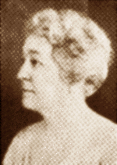
We Shall Keep the Faith
by Moina Michael, November 1918
Oh! you who sleep in Flanders Fields,
Sleep sweet - to rise anew!
We caught the torch you threw
And holding high, we keep the Faith
With All who died.
We cherish, too, the poppy red
That grows on fields where valor led;
It seems to signal to the skies
That blood of heroes never dies,
But lends a lustre to the red
Of the flower that blooms above the dead
In Flanders Fields.
And now the Torch and Poppy Red
We wear in honor of our dead.
Fear not that ye have died for naught;
We'll teach the lesson that ye wrought
In Flanders Fields.


Inspiration
Having read John McCrae's poem 'In Flanders Fields' Moina Michael made a personal pledge to 'keep the faith'. She felt compelled to make a note of this pledge and hastily scribbled down a response entitled "We Shall Keep the Faith" on the back of a used envelope. From that day she vowed to wear a red poppy of Flanders Fields as a sign of remembrance.

From: Elizabeth Coble
Date: 11/13/2008 5:11:20 PM
To:
Subject: Assistance for U.S. Army War College Strategy Research Paper (Thesis)

Ladies and Gentlemen,

Most of you know me, but for overall consistency, a quick intro..... I am LTC Elizabeth Coble. While I have served in two Airborne units, I have never been assigned to the 82d, but I am a life member of the 82d Airborne Division Association. I have two masters degrees. My first one was in History. My specialty is 20th US Military History. I did my thesis on LTG James Gavin. I am currently a student at the U.S. Army War College. I wrote a Strategic Leadership paper on LTG Gavin for a recent class requirement.

I am doing my Strategy Research Paper (thesis equivalent) at the War College on Operation MARKET GARDEN, specifically the 82d's AO. I was also approved to do an Elective on 82d Veterans' Oral History of MARKET GARDEN.

It is my goal in these two projects to help capture more of the 82d's history, especially from Veterans who have not yet told their stories.

I am asking for your assistance in finding men who are still alive who participated MARKET GARDEN and would be willing to talk with me about it. I am also interested in any unpublished accounts of MARKET GARDEN that I could use. This could include audio or video tapes, handwritten notes or letters, or typed documents.

I am willing to travel to do interviews, if the Veteran is not willing to do a telephonic interview. I would also pay for any associated costs, like photocopying or audio tape copying, that may be required.

I can use the info and do the interviews through late February 2009. Then I would have to stop to be able to write my findings in time to meet the suspense date.

If you support this effort, request that you send this out to your 82d Veterans, Family and Friends members, or others who might be willing and able to help.

I apologize in advance if I am not sending this to all of the correct people. For example, I know that I should have sent this to Steve Frazier and Manny DeJesus, but I do not have their E:Mail addresses. Please forward as required.

Please let me know if you have any questions. Thanks in advance for your assistance.

Liz

LTC Elizabeth Coble
cell
alternate email:
Many thanks goes to Egbert and his friend Jeroen C. Koppes. Also thank you Otis Sampson Jr for your help. It is members like this that makes Family & Friends the great success it has become.

Airborne,

Jim

-------Original Message-------

From:
Date: 11/14/2008 4:35:37 PM
To:
Subject: website update

Hello Veterans and F&F,

Website update: www.505RCT.org

A friend of F&F member Egbert van de Schootbrugge has been able to undo most of the damage committed by the hackers. His name is Jeroen C. Koppes, he is a top-notch coder, and he has restored the 'stores', 'links' and 'publications'. He is also working on restoring the photo album, but this is a big task.

If you get the chance, please visit these other websites built by Jeroen.
http://www.ww2awards.com
http://www.american-divisions.com

Otis Sampson Jr. also took steps to help resolve these issues. Thank you Jeroen, Egbert, and Otis!

John Sparry
-------Original Message-------

From: Barbara Gavin Fauntleroy
Date: 11/14/2008 5:46:15 PM
To: 'Family & Friends 505 RCT'
Subject: RE: Birthday

Dear Emile,

Thank you for your kind "Happy Birthday" wishes. I did have a very nice day
with most of my family with me. Emile, I look forward to seeing you next
year as my husband, Clancy, and I travel on the Static Line tour. Although
we have lost our leader, Don Lassen, we will be there on the trip the end of
May.

My best wishes to you,

Barbara

-----Original Message-----
From: Family & Friends 505 RCT [
Sent: Thursday, November 13, 2008 12:51 AM
To: Family & Friends 505RCT Membership
Cc: Barbara Gavin Fauntleroy
Subject: Birthday

-------Original Message-------

From: Emile Lacroix <
Date: 11/12/2008 5:51:20 PM
To: FAMILY and FRIENDS 505RCT <
Subject: Birthday

To Barbara Gavin

From Emile lacroix

And the Belgian
82nd Airborne "All American" J.G.
Friends
Cindy,

This is all I have on your grandfather, Samuel Webber. Don may know more since he was a Sgt. in F Company.

GO#19/44 F-Company Weber, Sr Samuel ASN# 39137653 CIB- Holland

Airborne,

Jim Blankenship
Past President & Founder
Family & Friends 505 RCT

-------Original Message-------

From: jsparry@comcast.net
Date: 11/18/2008 6:40:48 AM
To: Family and Friends 505RCT
Cc: gregory
Subject: FW: Grandfather

-------------- Forwarded Message: --------------
From: <gregory
To: <jsparry@comcast.net
Subject: Grandfather
Date: Wed, 29 Oct 2008 18:23:12 +0000

> I am searching for any information about my grandfathers military history.
> His name was Samuel Weber.
> All I have is a picture of his headstone,and his service
> number. On his headstone it says:PFC 505 PRCHT INF REGT BSM: his sevice
> number is {39-137-653} If you have any information on him that would be
> great. If not maybe you could give me some other options.
> He was killed when my father was only 9.And we dont know much about him.
> Thank You,
> Cindy(Weber)Gregory
-------Original Message-------

From: john mccann
Date: 11/23/2008 6:10:40 AM
To: Family & Friends 505 RCT
Subject: Remembrance Day in GB & Ireland.

Dear Family & Friends,

Recently, in Ireland and Britain, we commemorated our war dead on Remembrance Sunday. This day is similar in many respects to your Veteran's Day. Leading up to it, the local newspaper in Cookstown asked me if I would like to contribute some stories and photographs from my book recalling the American presence in the area during WWII. Well, immediately I thought of the 505 and preceded to send them enough material for a three page spread. The PDF's are attached to this and a following email. They are quite large, so I hope you can download, read and enjoy them.

Also attached is a PDF file of a poster they produced to advertise the Remembrance Day issue of the paper. It was visible in almost every shop window throughout most of Northern Ireland. Just in case some of you do not recognize the men visible, they are:
Lieutenant Stanley Weinberg (front middle) and members of ‘B’ Company taking a break from weapons practice at Ballymultrea firing range, February 1944.

Best wishes to you all for the upcoming Christmas & New Year period.

John McCann.

(To see articles and poster, see this web page: http://www.505rct.org/theUK.asp - JS)
-------Original Message-------

From: Frits Janssen
Date: 11/24/2008 7:40:16 AM
To: Family & Friends 505 RCT
Subject: Mayo S. Silvey

Hi all,

I am looking for information on Lt. Col. Mayo S.Silvey. As far as I know he was the ordnance officer in HQ.

Thanks in advance.

Frits Janssen
Mook, The netherlands
We have received word that Bill Tucker passed away Friday evening from kidney failure.
Bill was a member of I Company, 505 PIR during WWII.

AIRBORNE ALL THE WAY

Jim Blankenship
Family & Friends 505RCT
-------Original Message-------

From: ROBERT GILLETTE
Date: 11/24/2008 5:47:49 PM
To: Family & Friends 505 RCT
Subject: Re: Taps Bill Tucker

To all:

The passing of Bob Murphy and Bill Tucker is like closing a chapter on the 505 history. I was a friend of both--unfortunately while each was a great guy in his own right, they became adversaries.

They had much in common. They each joined the 505 as replacements in North Africa and did not share the early days of the 505. They each had a profound interest in preserving the history of the 505. They both lived in Massachusetts. They were both lawyers. They each wrote one or more books about WWII.

Bill Tucker was a major player in the C-47 Club. Bob Murphy became a major player in the 505th RCT Assn. The C-47 Club membership began and remained largely composed of 505ers, some of which never were active in the 505 RCT. Both the C-47 Club and the 505 RCT made friends in Europe and made major contributions to monuments there.

The difficult relationship between the two had many elements which I will not try to define. One can only wonder what they might have accomplished had they collaborated together. It just goes to show that old paratroopers are just like the rest of the population--they just don't see eye to eye on everythng whether it be politics, religion, or personal relationships.

Written reluctantly but for historical clarity, Bob Gillette

----- Original Message -----
From: Family & Friends 505 RCT
To: F&F Undisclosed Recipient
Sent: Saturday, November 22, 2008 2:28 PM
Subject: Taps Bill Tucker

We have received word that Bill Tucker passed away Friday evening from kidney failure.
Bill was a member of I Company, 505 PIR during WWII.

AIRBORNE ALL THE WAY

Jim Blankenship
Family & Friends 505RCT

From: jsparry
Date: 11/26/08 21:27:16
To: Family and Friends 505RCT
Subject: November Panther

Hello,

The November issue of the Panther is now on the website. Great work as usual Don.
http://www.505rct.org/panther/panther.asp
John

From: vivianroger
Date: 11/27/2008 6:18:19 AM
Subject: Giving thanks!!!

Hello friends and family,

All of us have something to be thankful for . . . . no matter the measure!!! And although we may be thankful each day of our lives, today we dedicate to a celebration of "giving thanks" all around the USA and across the world wherever Americans may be on this day !!! And often, we share this celebration with other friends of other origines, opening our hearts and our homes, blessing and sharing the food together. Today is a "family day", no matter how we define that term !!!!

H A P P Y T H A N K S G I V I N G ! ! ! ! !

And may we all be blessed !!!

Vivian & Rodolphe Roger
Association U. S. Normandie "mémoire et gratitude"

Subject: Happy Thanksgiving: Then & Now

Happy Thanksgiving to all of you !

Last year it was our second attempt of grilling ‘a bird’, but we've still gotta try again, again and again ;-)

Turkeys and Thanksgiving are a (mainly) American thing, but the whole world could do with some Thanksgiving and
Reflecting on ones efforts every now and then. What have you done for those around you ? Especially in these days.
Makes you humble to realize what you HAVE got, who ARE around you and who you LOVE…

And whatever you guys are eating today… take a look at the Menu of B-Co 502nd PIR, Thanksgiving 1942 at Fort Bragg.
A 66 year old Thanksgiving Menu: http://pararesearchteam.com/502/1942-Thanx.html

My best wishes to all of you.
All the best in life & health !

Donald & Sophia van den Bogert
www.pararesearchteam.com

AIRBORNE ALL THE WAY

Jim Blankenship
Family & Friends 505RCT
Thanks Ellen for sending this to F&F.
Thank You Gene for a fine tribute in Bob's memory. Bob was a fine man and an honor to his 505RCT Regiment and 82ABN Division.
He will be in the thoughts and hearts of many citizens all over Europe and especially in Leceister (Quorn) England and Saint Mere Eglise,
France. He touched so many lives wherever he went. We will all miss him so very much.
AIRBORNE ALL THE WAY

Jim Blankenship
Family & Friends 505RCT

-------Original Message-------

From: Ellen Peters
Date: 11/27/08 12:01:32
To: Family and Friends of the 505th RCT
Subject: Fw: Mr. Robert (Bob) Murphy has been honored by a gift to the USO

I received the below from the USO. Gene Garren has made a gift to them in Bob's memory. Thank you, Gene, for honoring our dear friend. It is still hard to believe he is gone. I think of Bob everyday and miss him more than I can say.

Ellen
--- On Wed, 11/26/08, > wrote:
From:
Subject: Mr. Robert (Bob) Murphy has been honored by a gift to the USO
To:
Date: Wednesday, November 26, 2008, 11:25 PM

Dear Ms. Peters,
We are pleased to inform you that the USO has received a donation in tribute to Mr. Robert (Bob) Murphy.
This gift will help the USO continue to provide morale-building services and entertainment to our military service personnel around the world.
We appreciate Mr. Garren's thoughtfulness and trust that you will find it a meaningful tribute as well.
Mr. Garren asked that we include the following message in our email notification to you:
Bob Murphy has a street named after him in Saint Mere Eglise, Normandy, France. Bob also wrote a book (No Better Place To Die) which is being made into a movie. Bob was always in Normandy each June for the D-Day events. He was an American and a Norman institution. We miss him more than one can say in words. A true hero, class act, and superb credit to the USA.

Emile......... That is very true. I did not mean to slight any of our friends in Belgium, Holland, Ireland, Scotland, England or France.
Bob had many friends wherever he traveled.

-------Original Message-------

From: Emile Lacroix
Date: 11/27/2008 6:25:24 PM
To: Family & Friends 505 RCT
Subject: Re: Mr. Robert (Bob) Murphy has been honored by a gift to the USO

Jim,
Don't forget how much my close friend Bob was also and will stay in the heart of so many people in Begium as well in Holland.
Emile lacroix
----- Original Message -----
From: Family & Friends 505 RCT
To: Family & Friends 505RCT Membership
Sent: Thursday, November 27, 2008 11:40 PM
Subject: Mr. Robert (Bob) Murphy has been honored by a gift to the USO

Thanks Ellen for sending this to F&F.
Thank You Gene for a fine tribute in Bob's memory. Bob was a fine man and an honor to his 505RCT Regiment and 82ABN Division.
He will be in the thoughts and hearts of many citizens all over Europe and especially in Leceister (Quorn) England and Saint Mere Eglise,
France. He touched so many lives wherever he went. We will all miss him so very much.
AIRBORNE ALL THE WAY

Jim Blankenship
Family & Friends 505RCT

-------Original Message-------

From: Ellen Peters
Date: 11/27/08 12:01:32
To: Family and Friends of the 505th RCT
Subject: Fw: Mr. Robert (Bob) Murphy has been honored by a gift to the USO

I received the below from the USO. Gene Garren has made a gift to them in Bob's memory. Thank you, Gene, for honoring our dear friend. It is still hard to believe he is gone. I think of Bob everyday and miss him more than I can say.

Ellen
--- On Wed, 11/26/08, > wrote:
From: >
Subject: Mr. Robert (Bob) Murphy has been honored by a gift to the USO
To:
Date: Wednesday, November 26, 2008, 11:25 PM
Dear Ms. Peters,
We are pleased to inform you that the USO has received a donation in tribute to Mr. Robert (Bob) Murphy.
This gift will help the USO continue to provide morale-building services and entertainment to our military service personnel around the world.
We appreciate Mr. Garren's thoughtfulness and trust that you will find it a meaningful tribute as well.
Mr. Garren asked that we include the following message in our email notification to you:
Bob Murphy has a street named after him in Saint Mere Eglise, Normandy, France. Bob also wrote a book (No Better Place To Die) which is being made into a movie. Bob was always in Normandy each June for the D-Day events. He was an American and a Norman institution. We miss him more than one can say in words. A true hero, class act, and superb credit to the USA.

From: Emile Lacroix
Date: 11/28/2008 2:24:24 PM
To: FAMILY and FRIENDS 505RCT
Subject: Bob Murphy visit at Belgian school Febr.2008

Jim,
Bob left a great impression on the children, teachers and other people who approched him during the visit he made at the Wasseiges, Belgium, school during our "after 82nd Airborne's march program" last February. His legendary kindness, specially with the children, and his availability to answer all their questions would never be forgotten and the announcement of his death left on them a feeling of deep sadness. The schcool staff wanted to place a panel with photo of his visit in the hall and also to express their felling about Bob by this letter we wrote with the lady Director.
Emile Lacroix

The Director,
the teachers
and the children
of the elementary school of the town of Wasseiges.

It is with a deep emotion that we learned the passing of Mr. Murphy.

The opportunity was given to us to meet and welcome Mr. Murphy, as part of the program of a pedagogic project “a historical homage to honor of the veterans parachutists of the of the Normandy aerial landing and Battle of the Bulge, and by that same occasion to also invite the Belgian veterans and an underground woman of the town of Wasseiges.”
Members of the town council, including the Mayor were also present to welcome Bob.

This was for us, children and teachers a meeting as much instructif than outstanding which happened last February 2008 at our elementary school of Wasseiges, Belgium, during “the after 82nd Airborne Division’s march program.”

All by himself, Mr Murphy was a book, a monument, a memory!

This memory of men, of American Paratroopers, who suffered in Normandy, in June 1944, in the Bulge and in other WWII battlefields.
He made us to share his experiences as much that a part of this history will remain engraved in our memories.

The emotion rendezvoused with remembrance… and we will never forget this meeting with the reality of the war.
This Normandy landing by our friends “the Allies” changed our history. Thanks to you and your friends, we are living in a free country, a free and peaceful Europe.
We never could thank them enough.

Today, Robert Murphy is gone… and there up in the sky shines a new star…

We will never forget you, Mr. Murphy!

The Director.
Christine Berlamont.

Legends of pictures about Bob Murphy's visit at the elementary school of Wasseiges, Belgium, during the program organized for the veterans by the 82nd Airborne "All American" J.G. after their march "In the footsteps of the 82nd Airborne Division", February 2008.

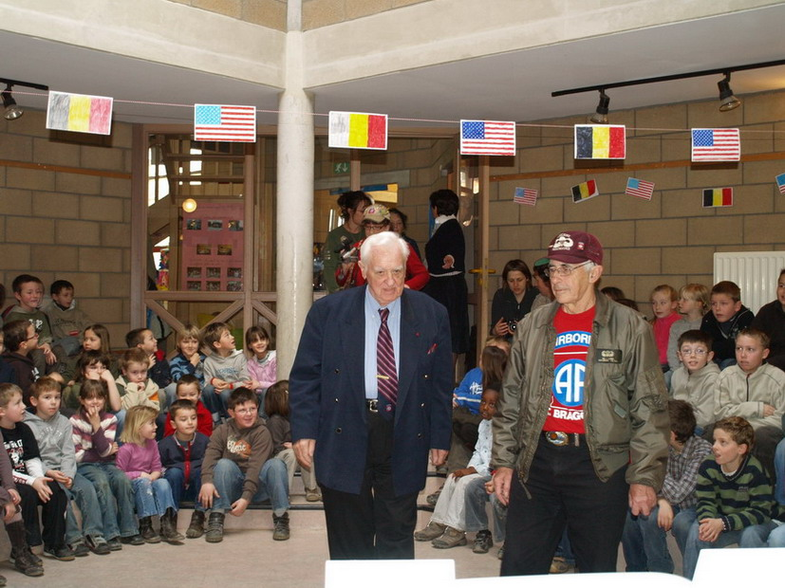
Pic137: After a visit to the children of the nusery classroom, Bob meets the kids of elementary school.

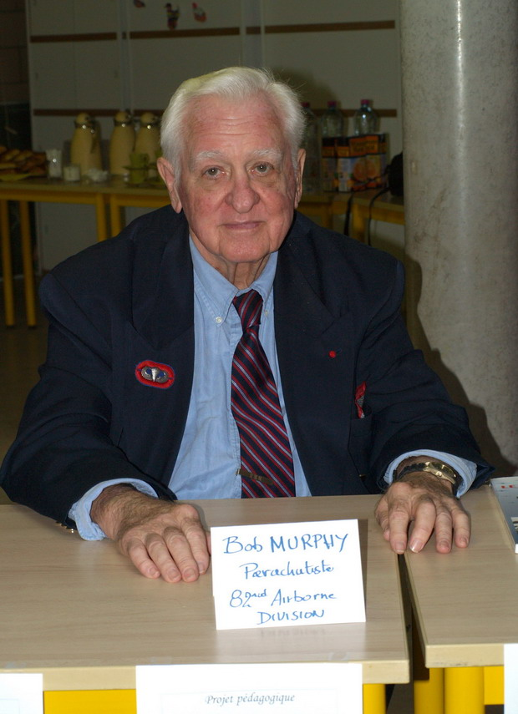
Pic149: Bob at the honor guest table addresses to the children.

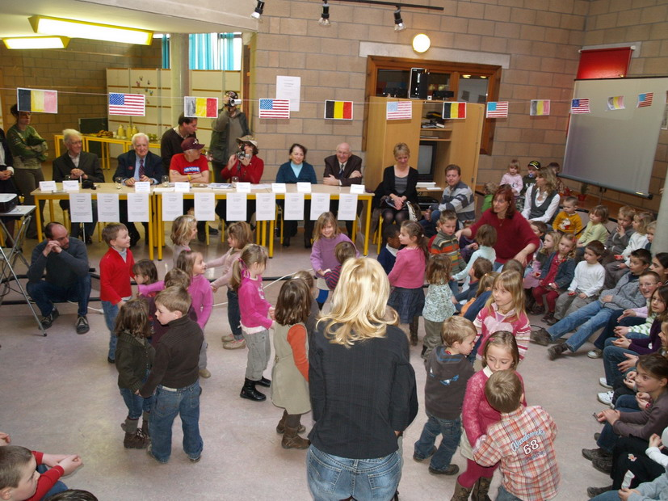
Pic166: The children of the nursery classroom perform a dance on Glen Miller music for
Bob and the other guests.

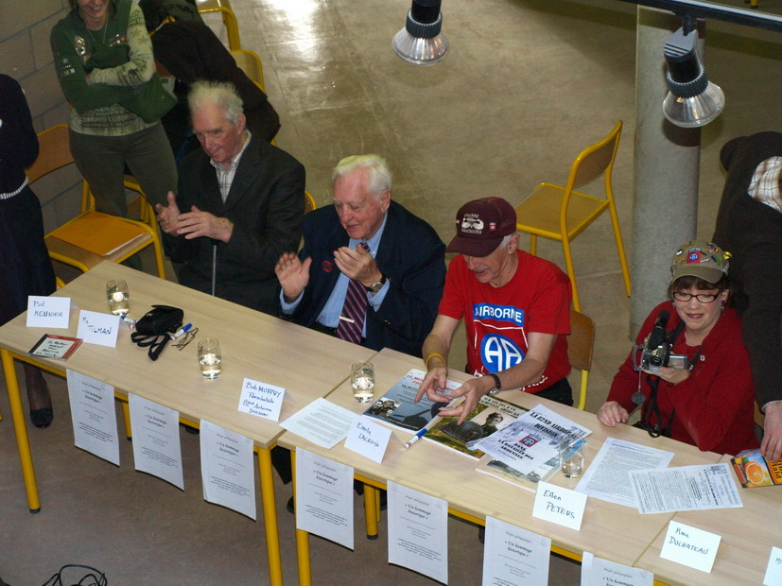
Pic171: Applauding: From L to R: a Belgian army WWII veteran, Bob Murphy, Emile Lacroix, Ellen Peters.

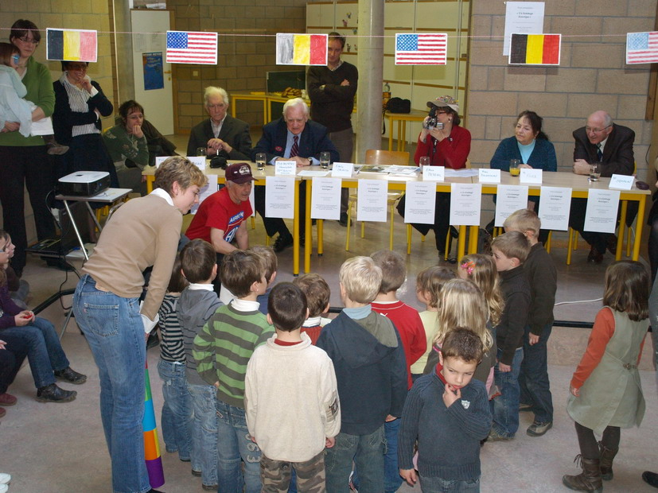
Pic180: Bob congratulates and thanks the little kids. Emile translate.To the right of Ellen
is a woman from Belgian underground who was interned by the Germans and the Mayor of Wasseiges

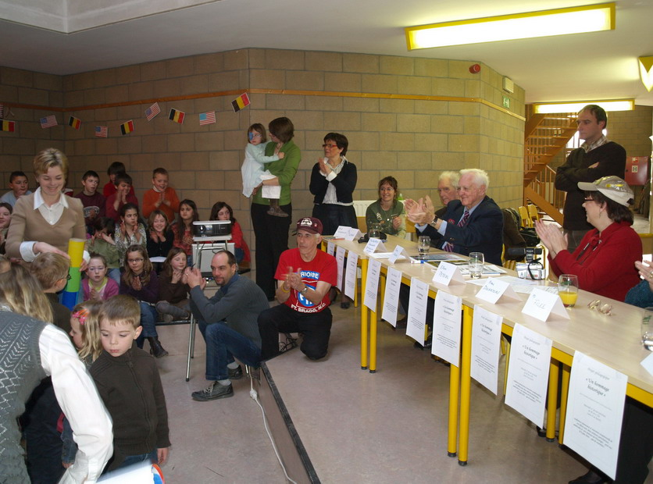
Pic181:The little children are applauded again for their performance.

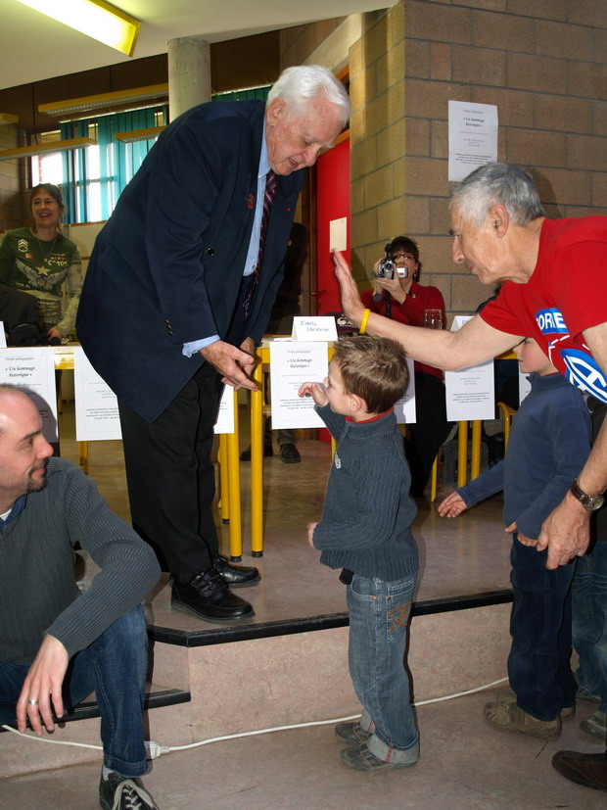
184
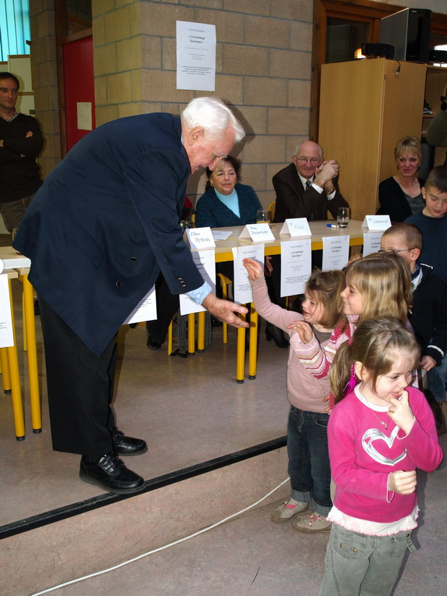

Pic184 & 193: Before to leave for their classroom the youngest children salute Bob who makes his famous "give me five" check hand with each of them at the great joy of children and all people present

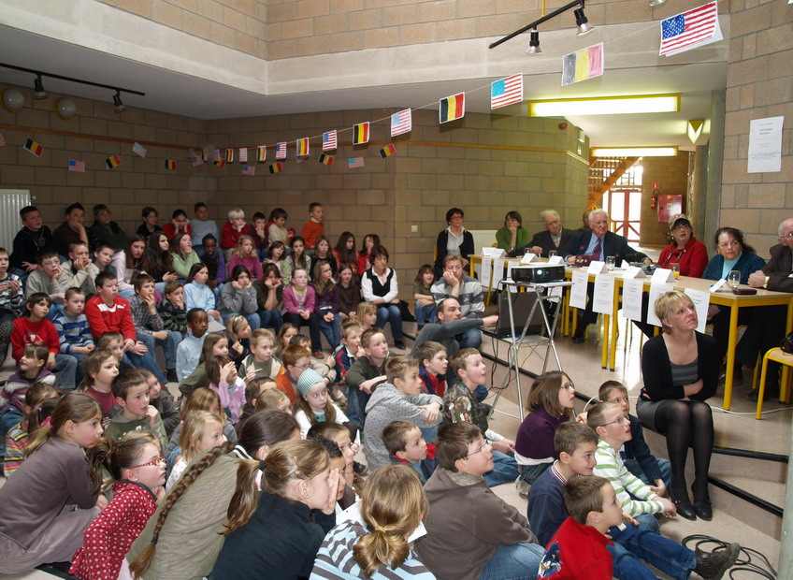
221
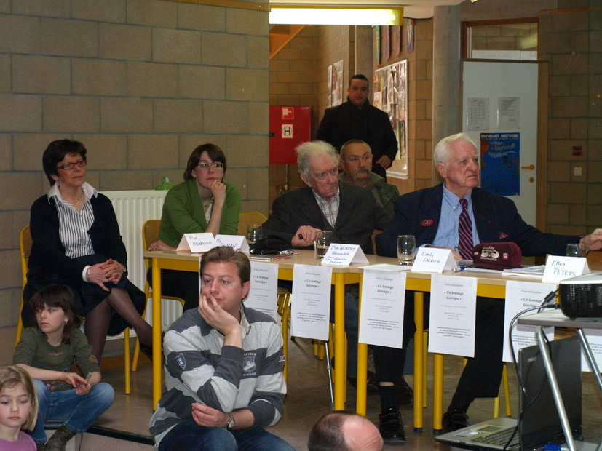
222
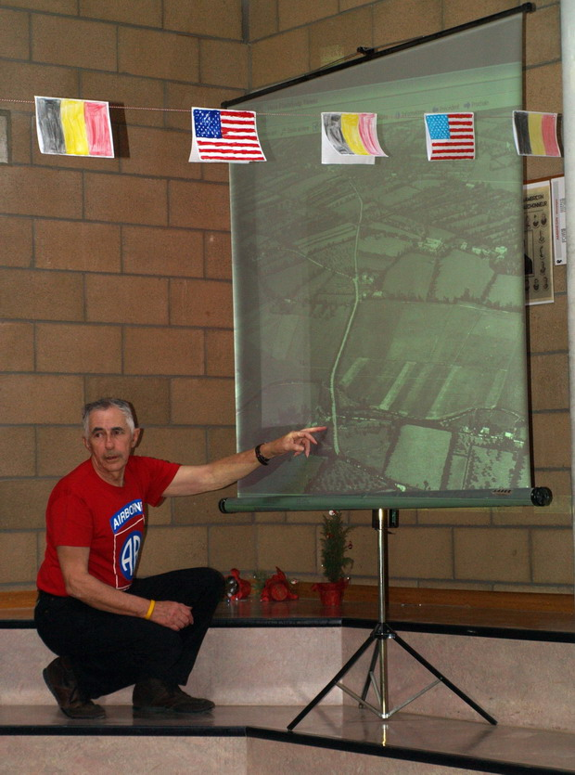
Pic 221, 222 & 224: Then came the conference by Bob about WWII, his paratrooper experience, illustrated by digital pictures on as screen and commented by Emile. The children asked a lot of questions to Bob about WWII and his witnesses.
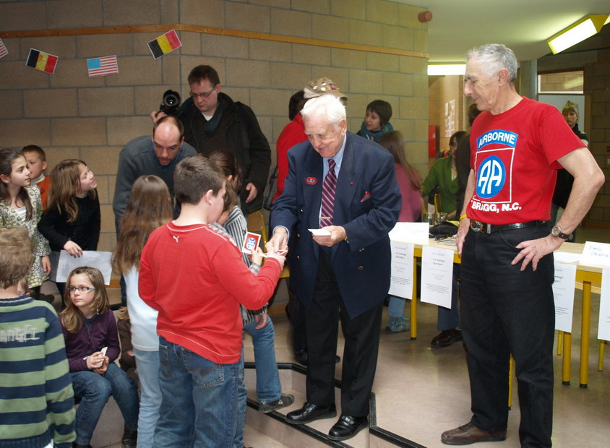
234
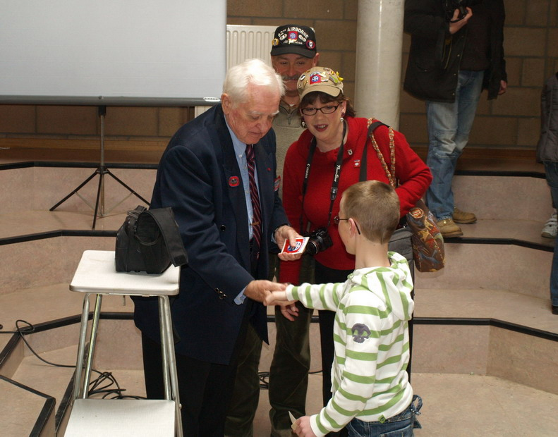
Pic 234 & 241: At the end of the conference each children is presented a sticker of the 82nd Airborne "All American" Jeep Group by Bob and check hand with him.

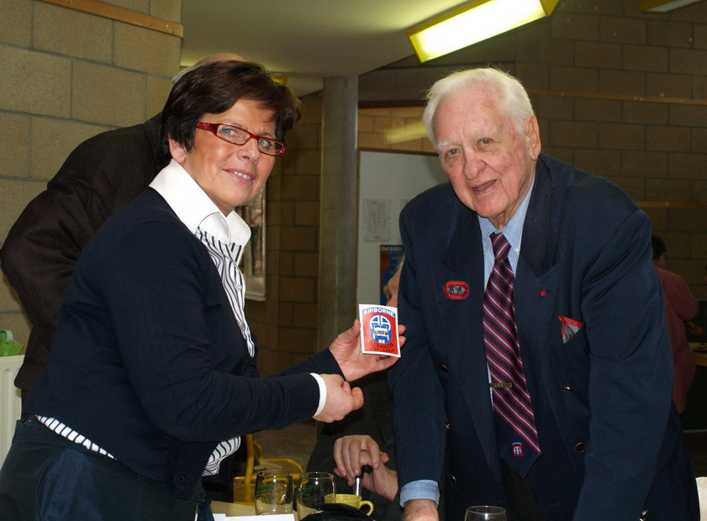
Pic 246: Mrs Christine Berlamont, Director of the Wasseiges Nursery and Elementary school poses with Bob Murphy. (a 82nd Airborne "AA" Jeeep Group sticker in hand)

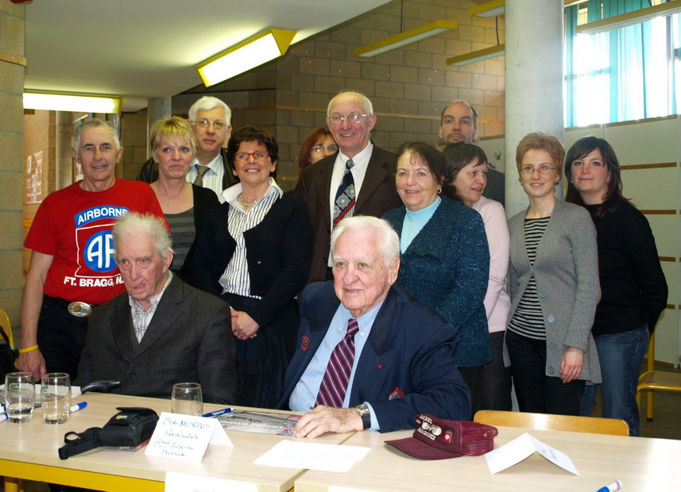
Pic 261: The lady Director with a part of the teachers, the Mayor, a Belgian veteran and undergound woman poses with Bob and Emile

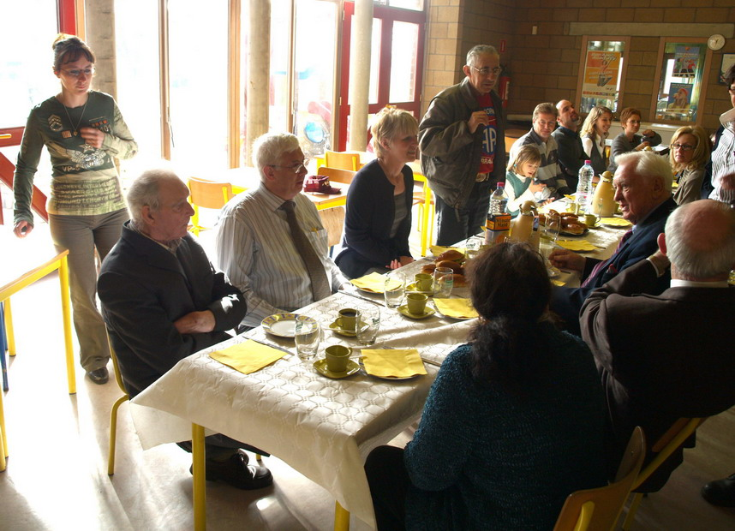
262
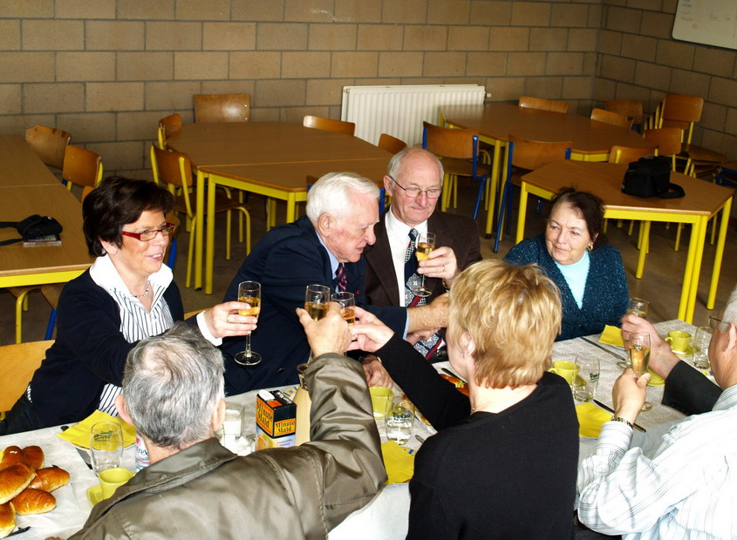
Pic 262 & 266: A lunch was offered in the restaurant of the school with the Director and teachers. Bob checks the friendship glass with all for a toast to the Airborne troopers and our American liberators.

We will never forget Bob Murphy's visit at our school, his kindness with the children and all of us and his disponibility to answer all questions. It was a great moment in our life to meet a man like him and we feel lucky that we had this opportunity. We wanted to welcome him again but, helas, it would be the only time.
LIST OF AIRBORNE BOOKS…COMPILED BY JIM BLANKENSHIP
FAMILY AND FRIENDS 505 RCT ASSOCIATION.

82nd. Airborne Division- 60th.Anniv. Edition Static Line Turner Publishing
82nd.Airborne Division History updated history of 82nd. Static Line $52.50 Turner Publ.
A Bridge too Far C. Ryan Amazon… price varies
A Time for Trumpets McDonald,Charles B. Quill
At the Point of no Return, 'Pictorial History of the American Paratroopers Prior to Normandy', Michel De Trez, D-Day Publishing, www.d-day-publishing.be $ 59.00
American Warriors, 'Pictorial History of the American Paratroopers in the Invasion of Normandy', Michel De Trez, D-Day Publishing, www.d-day-publishing.be $ 59.00
Airborne Tom Clancy Static Line $12.50
Airborne Album John Andrews Static Line $30.00
Airborne-Combat History of US Airborne Flannagen, E.M. Ballentine Books
All American All The Way Phil Nordyke author/any book store
All the Way to Berlin James Megellas Amazon.com Ballantine
Ardennes Charles Whiting Static Line $15.00
Beyond Valor/WWII Ranger & Abn. Vets O'Donnell,Patrick Free Press
Bitter Victory-The Battle for Sicily 1943 D'Este, Carlo Harper Collins
Citizen Soldiers Ambrose Amazon.com
Combat Jump Ed Ruggero Static Line/Amazon $24.95
D Day Stephen Ambrose Amazon.com
D Day- As They Saw It Lord Carver Amazon.com $10.78
D Day-The First 24 Hours Will Fowler Amazon.com Amber Books
Dawn of D-Day-These Men Were There Howarth, David Amazon.com $19.95
D-Day Companion, The Penrose, Jane Amazon.com $11.98
Descending from the Clouds Spencer/Gayle Wurst author/Gayle Wurst $32.95 Casemate
Devils in Baggy Pants Carter, Ross S. Amazon.com $16.35
Down to Earth..507 PIR in Normandy 6/6 Morgan, Martin K Schiffer
Drop Zone Normandy Napier Crookenden Amazon.com
Drop Zone Sicily William Breuer Static Line/Amazon
Echoes of the Warriors George Jacobus contact author
Fierce Individualist Dennis O'Loughlin E Co. comrade of Otis Sampson/from his niece
First Men In, The Ed Ruggero Amazon.com/ June 2006 $26.95 Harper-Collins
Fortitude: The D Day deception Campgn. Hesketh, Roger Amazon.com Overlook Press
Four Stars of Honor Phil Nordyke coming in October '06
From Skys of Blue"Experiences w/82 ABN Baugh, James Emory Universe
Glide to Glory- 325 GIR Memoirs Richlack,
Glidermen of Neptune/D Day glider attack Masters, Charles Amazon SIU Press
Greatest Generation, The Tom Brokaw Amazon.com
Honor Roll Fr.Thuring Airborne Museum/Groesbeek
I Maintain The Right Peter Turnbull amazon.com
Let's Go- History of the 325 GIR Pierce, Wayne Amazon.com
Longest Day, The Cornelius Ryan any book store $15 Simon & Schuster
Memoir of of the 456 Parachute F.Artillery Starlyn Jorgensen unpublished
Memoirs of Arthur B. Kroos Sheboygan County Hist. Soc.80AA & Aide DeCamp to Gen.Ridgeway
Night Drop/Airborne invasion of Normandy Marshal, S.L.A. Amazon Battery press
No Better Place To Die Bob Murphy revised edition June '06
On Killing Dave Grossman Boston,Little, Brown,1995
On Time, On Target J. McKenzie amazon.com
On To Berlin James Gavin Amazon.com $10.00 Viking
Our Finest Day- D Day June 6, 1944 Amazon.com
Overlord Hastings, Max Amazon.com $22.95
Parachute Soldiers Tucker, Bill Int.Abn.books
Paratrooper Gerry Devlin St.Martins
Paratrooper-Life of Gen.Jim Gavin Booth & Spencer Amazon.com Simon/Schuster
Passing Through- The 505 in N. Ireland John McCann author/Gayle Wurst $32.95
Pathfinder- First In- Last Out/Viet Nam Burns, Richard Amazon.com Ballintine Books
Put on Your Boots and Parachutes- Derek Wills Amazon.com
Ready Al Langdon out of print (but not for long)
Rendevous at Rochelinval Tucker, Wm. Int.Airborne Books
Ridgeway's Paratroopers Clay Blair
Roll of Honor Fr. Thuring Bevrijdings museum/Groesbeek,The Netherlands
Sainte Mere Eglise Alexander Renaud
Sainte-Mere-Eglise, Photographs of D-Day, Michel DeTrez, D-Day Publishing, www.d-day-publishing.be $59.00
Search for Members of the 505PIR WWII Bob Gillett-James Meyers self published records
Stand Up & Hook Up Buck Dawson Static Line $15.00
Stanley Weinberg Letters online Library of Congress
Stanley Weinberg--WWII Remembrances Weinberg, Ann self published memoir Weinberg, Ann
Stragedy Frank Maile author Trafford
Strike & Hold/Memoir of 82 Abn WWII Burriss, T moffatt Amazon.com $19.95 Brassey's
The Way We Were #2, Col. Bob Piper, Michel De Trez, D-Day Publishing, www.d-day-publishing.be $24.00
The Way We Were #3, Doc McIlvoy & his Parachuting Medics, Michel De Trez, D-Day Publishing, www.d-day-publishing.be $36.00
The Way We Were #4, Col. Ben Vandervoort, Michel De Trez, D-Day Publishing, www.d-day-publishing.be $30.00
Thirty Five Days in Normandy Tucker, Bill Int.Abn books
Time out for Combat Otis Sampson amazon.com
Treasures in My Heart letters-John Ray-F-Co
Triple Nickles-Story of the 555 Bradley Biggs Static Line $15.00
US Airborne Forces Gregory, Barry Amazon.com Gallery Books
US Paratrooper........1941-45 Smith,Carl-Chappell, M. Oxford

Rob;
Thank you for your kind words. We owe so much to these men who defended freedom for their country as well as our allies. It has been an honor to know many of them and their courage in the face of extreme danger. It is our duty as Family & Friends of the 505 RCT to see that their bravery is never forgotten.

AIRBORNE ALL THE WAY

-------Original Message-------

From: Buck, Robert
Date: 11/29/2008 10:53:01 AM
To: Family & Friends 505 RCT
Subject: Bob (and all the WWII Paratroopers) were Heroes to This Generation of Soldiers

Jim:
I had these photos from our jump into SME (June 2005) I recall hearing all of the Rangers with me speak endlessly about how much they admired the accomplishments and bravery of the WWII-era paratroopers. We indeed owe them all a debt of gratitude that could never be repaid. So many young Americans waste their days idolizing TV or movie stars that have done nothing to make this nation better when their time should be spent studying the unbelievable exploits of the Greatest Generation. Often is easy to forget given their soft-spoken nature, slowed movement, and gray hair that years ago when they were young men they saved freedom from the clutches of tyranny and oppression.

As in all previous Thanksgivings, I gave thanks for men such as those that filled the ranks of the 505 - men that realized there were causes greater than themselves. I am reminded of an old quote - what is done in life for yourself dies with you, but what you shall do for others lives on and shall remain immortal. Words such as these remind us those men with names such as: Blankenship, Lassen, Murphy, and Tucker are indeed immortal so long as somewhere citizens continue to cherish freedom.

With kindest regards,

Rob Buck
82nd ABN DIV, 75th Ranger (ret)
Dear Ms. Peters,
We are pleased to inform you that the USO has received a donation in tribute to Mr. Robert (Bob) Murphy.
This gift will help the USO continue to provide morale-building services and entertainment to our military service personnel around the world.
We appreciate Mr. Garren's thoughtfulness and trust that you will find it a meaningful tribute as well.
Mr. Garren asked that we include the following message in our email notification to you:
Bob Murphy has a street named after him in Saint Mere Eglise, Normandy, France. Bob also wrote a book (No Better Place To Die) which is being made into a movie. Bob was always in Normandy each June for the D-Day events. He was an American and a Norman institution. We miss him more than one can say in words. A true hero, class act, and superb credit to the USA.

SME Dinner JUN 2005.jpg
Bob Murphy and Rob Buck - La Fiere JUN 05.jpg
Bob -Howard - and Bill with Rangers JUN 2005.jpg
Bob Murphy and Bill Sullivan and troops.jpg

-------Original Message-------

From: Ellen Peters
Date: 11/29/2008 5:14:16 PM
To: 'Family & Friends 505 RCT'
Subject: RE: Bob Murphy visit at Belgian school Febr.2008

I remember well the visit to the school. First Bob visited two classrooms with some of the younger children. Then we to the main assembly area where all the classrooms met. I remember he spoke about the importance of freedom and what freedom meant. Those kids loved Bob and hung on his every word. (Me, too!) Bob was truly in his element when he was with children. After Bob spoke, they had a Q&A session and those kids really had a lot of questions for Bob. There was a Belgian veteran there and a woman who at 16 years old was held as a political prisoner by the Germans until she managed to escape. They were both very interesting and I enjoyed talking with them. After the assembly, we attended a luncheon. It was a lovely day.

Ellen

From: Family & Friends 505 RCT []
Sent: Friday, November 28, 2008 11:07 PM
To: Family & Friends 505RCT Membership
Subject: Fw: Bob Murphy visit at Belgian school Febr.2008

-------Original Message-------

From: Emile Lacroix
Date: 11/28/2008 2:24:24 PM
To: FAMILY and FRIENDS 505RCT
Subject: Bob Murphy visit at Belgian school Febr.2008

Jim,
Bob left a great impression on the children, teachers and other people who approched him during the visit he made at the Wasseiges, Belgium, school during our "after 82nd Airborne's march program" last February. His legendary kindness, specially with the children, and his availability to answer all their questions would never be forgotten and the announcement of his death left on them a feeling of deep sadness. The schcool staff wanted to place a panel with photo of his visit in the hall and also to express their felling about Bob by this letter we wrote with the lady Director.
Emile Lacroix

The Director,
the teachers
and the children
of the elementary school of the town of Wasseiges.

It is with a deep emotion that we learned the passing of Mr. Murphy.

The opportunity was given to us to meet and welcome Mr. Murphy, as part of the program of a pedagogic project “a historical homage to honor of the veterans parachutists of the of the Normandy aerial landing and Battle of the Bulge, and by that same occasion to also invite the Belgian veterans and an underground woman of the town of Wasseiges.”
Members of the town council, including the Mayor were also present to welcome Bob.

This was for us, children and teachers a meeting as much instructif than outstanding which happened last February 2008 at our elementary school of Wasseiges, Belgium, during “the after 82nd Airborne Division’s march program.”

All by himself, Mr Murphy was a book, a monument, a memory!

This memory of men, of American Paratroopers, who suffered in Normandy, in June 1944, in the Bulge and in other WWII battlefields.
He made us to share his experiences as much that a part of this history will remain engraved in our memories.

The emotion rendezvoused with remembrance… and we will never forget this meeting with the reality of the war.
This Normandy landing by our friends “the Allies” changed our history. Thanks to you and your friends, we are living in a free country, a free and peaceful Europe.
We never could thank them enough.

Today, Robert Murphy is gone… and there up in the sky shines a new star…

We will never forget you, Mr. Murphy!

The Director.
Christine Berlamont.

215 - At the school.JPG
208 - Bob getting high fives from the children.JPG
207 - The children present a poster to Bob.JPG

-------Original Message-------

From: John Cowman
Date: 12/3/2008 8:23:10 AM
To: 'Family & Friends 505 RCT'
Cc:
Subject: JLC Expeditions & Normandy (Update)

Jim,
It’s so good to talk with you too! It has been a tough year for all in losing some of our veteran friends. Regarding this weekend, I have opened two businesses in Kennesaw, GA (3048 Cherokee Street). The primary retail store is a custom frame shop called Main Street Frames where we create & frame artwork, shadow boxes, flags, certificates and whatever is precious to customers in the form of memorabilia, artwork, etc. In addition, I created JLC Expeditions, Inc. doing business as Tour Normandy D-Day tour group company in an effort to keep the Normandy memories alive and provide the future opportunity for others to experience what many of us have had the pleasure of doing for many years now (tournormandydday.com).
This weekend (Sat, 6 Dec) we are having the Grand Opening for both business. We have scheduled a live radio remote with the 106.7 True oldies (11:00 - 1:00); Mayors ribbon cutting (Noon); Santa Clause (12:00 - 2:00); Numerous WW II D-day Veterans (10:30 - 2:30) signing books, taking pictures, telling stories; WW II Era Jeep Rides & Display; with breakfast & lunch catered. One of my business goals is to create and start a WW II D-day Museum in Kennesaw at the business location allowing anyone in the Atlanta area to drop in and experience what our Greatest Generation accomplished during WW II.
I would like to personally invite all the 505 Family and Friends membership to stop in and say hello anytime, especially this Saturday. If there are any WW II Veterans in your group that are interested in participating Saturday, I would be so honored to include them in our festivities too! Please call me at (770) 856-5151 so we can be prepared for there attendance. Again it’s good to talk with you Jim.. I’m already looking forward to the 65th D-Day Anniversary in Ste Mere Eglise next June…
JOHN L. COWMAN, President
JLC Expeditions, Inc.
Main Street Frames
3048 Cherokee St.
Kennesaw, Georgia 30144
Phone: 678.331.1619

From: Family & Friends 505 RCT []
Sent: Tuesday, December 02, 2008 4:16 PM
To: John Cowman;
Subject: email addresses

John.............Good talking to you.
Good luck with your new tour company.
AIRBORNE ALL THE WAY

Jim Blankenship
Past President & Founder
Family & Friends 505RCT

From:
Date: 12/9/2008 11:31:07 PM
To:
Subject: C-47 Question

Okay,

I've only made two jumps from a C-47 and the one I jumped was no-doubt modified after the war. Who here can answer a question someone has asked me?

This came about, as this guy sent me a You-Tube video of the WW2 Airborne Demo Team making a jump from a C-47. He asked me if there were two anchor-line cables in the aircraft? Or, how do you standup/hookup in a C-47? Do both sides of the a/c get up and lock their snap fasteners on the cable the best way they can on a single anchor-line (C-47 only had the left-side door, unlike the C-46)? Or does the first man on the right-hand side watch for the last man from the left to exit and immediately follow him? I'm sure someone on the list has a good memory!

This is his exact question to me:

Tim, Look, you have a left door only on the C-47 and the troops are sitting on both sides. So, did the right side guys face the front of the plane and come around behind the left side (door side) and hook up and they all went as a single stick? Thanks, George

Tim Roop
www.ww2dday.com
-------Original Message-------

From:
Date: 12/10/2008 10:21:06 PM
To: f
Subject: Re: C-47 Question

YOUR QUESTION BEFORE WE JUMPED. WHEN WE WERE IN THE STATES WE WOULD WATCH THE GREEN LIGHT WHEN IT WENT OFF THE RED LIGHT WOULD COME ON JUMP MASTER STAND UP AND HOOK UP CHECK EQUIPMENT AND BE READY TO JUMP. YOU COUNTED AFTER YOU LEFT THE DOOR ONE THOUSAND TWO THOUSAND THREE THOUSAND AND HOPE SHE OPENED. WHEN WE JUMPED INTO NORMANDY OUR JUMP MASTER HOLLER UP TO THE PIOLET RAISE THIS SO AND SO UP SO WE CAN JUMP BUT WE WERE READY TO JUMP WHEN WE HIT THE COAST OF FRANCE. I DONT REMEMBER A GREEN LIGHT IN FRANCE WHEN THE RED LIGHT CAME ON WE WERE GONE AND HIT THE GROUND IN A HURRY. I DONT THINK WE WERE MUCH OVER FOUR HUNDRED FEET UP WHEN WE JUMPED THAT MORNING JUNE 6 1944. MY CHUTE NO MORE THAN OPENED AND I WAS ON THE GROUND.

I HOPE THIS HELPS YOU OUT. IF I CAN HELP ANYMORE LET ME KNOW.

HOWARD HUEBNER

n a message dated 12/10/2008 11:17:25 A.M. Eastern Standard Time, net writes:
-------Original Message-------

From: Anton van Ensbergen
Date: 12/10/2008 8:04:07 AM
To: Family & Friends 505 RCT
Subject: Re: C-47 Question

Hi,

I am a member of the Liberty Jump Team (www.libertyjumpteam.org) and went thru jump school in April 2007. Made my first 5 jumps EVER from a C47. After that we went to Normandy with the team and performed 3 commemorative jumps of which 1 was a night jump. Later that year we jumped to commemorate Market Garden 2 times.
So all in all I can say: My first 10 jumps where C47 exits with static line and round canopy's.
http://nl.youtube.com/watch?v=UbXI5eomZQE

You got some questions that maybe this YouTube film can answer. It was made on one of our Normandy jumps this year and Dale Dye's film crew was also on board. The film you see was made by a team member with a helmet camera.
http://nl.youtube.com/watch?v=tVYsSnLxJQQ

We have a jumpmaster who is not part of the stick, he throws wind drift indicators to pinpoint our exit point. Mind you we don't want to land outside our relative small dz's at demonstrations. Most of the time we do not go out as one stick, on behalf of the spectators it is more interesting to see the C47 pass several times, exiting 2, 3 or 4 small sticks. Also most of our dz's, although part of historical dz's, are smaller then when our hero's jumped in 1944. All this is different from what they did.

We use the following sequence of commands:

- 10 minutes
- 6 minutes
- Get ready
- Stand up
- Hook up
- Check equipment
- Sound of equipment check
- One minute
- At the door
- Go

We got one anchor line and as far as my knowledge goes, they did too back then.
Get ready signal was given by activating the red light.
The pilot determined the exit point and "Go" by activating the green light.

So I also would like to know the answer to Tim's questions and in what way commands where different

Anton
----- Original Message -----
From: Family & Friends 505 RCT
To: Family & Friends 505RCT Membership
Sent: Wednesday, December 10, 2008 1:33 PM
Subject: Fw: C-47 Question

-------Original Message-------

From:
Date: 12/9/2008 11:31:07 PM
To:
Subject: C-47 Question

Okay,

I've only made two jumps from a C-47 and the one I jumped was no-doubt modified after the war. Who here can answer a question someone has asked me?

This came about, as this guy sent me a You-Tube video of the WW2 Airborne Demo Team making a jump from a C-47. He asked me if there were two anchor-line cables in the aircraft? Or, how do you standup/hookup in a C-47? Do both sides of the a/c get up and lock their snap fasteners on the cable the best way they can on a single anchor-line (C-47 only had the left-side door, unlike the C-46)? Or does the first man on the right-hand side watch for the last man from the left to exit and immediately follow him? I'm sure someone on the list has a good memory!

This is his exact question to me:

Tim, Look, you have a left door only on the C-47 and the troops are sitting on both sides. So, did the right side guys face the front of the plane and come around behind the left side (door side) and hook up and they all went as a single stick? Thanks, George

Tim Roop
www.ww2dday.com

-------Original Message-------

From: GUY MOODY
Date: 12/12/2008 6:09:11 PM
To: Family & Friends 505 RCT
Subject: Re: Re: C-47 Question

If I remember, when you hook up, you would stagger the static line hooks. First man on the door side would hook up then the first man in the other stick would hook up, and so on.

Guy Moody
----- Original Message -----
From: Family & Friends 505 RCT
To: Family & Friends 505RCT Membership
Sent: Thursday, December 11, 2008 11:43 PM
Subject: Fw: Re: C-47 Question

-------Original Message-------

From:
Date: 12/11/2008 10:24:11 AM
To:
Subject: Re: C-47 Question

GOT MY LIGHT TURNED AROUND SORRY ABOUT THAT.

HOWARD JUST BEAR WITH AN OLD PARATROOPER.

In a message dated 12/11/2008 12:48:05 A.M. Eastern Standard Time, writes:
-------Original Message-------

From:
Date: 12/10/2008 10:21:06 PM
To:
Subject: Re: C-47 Question

YOUR QUESTION BEFORE WE JUMPED. WHEN WE WERE IN THE STATES WE WOULD WATCH THE GREEN LIGHT WHEN IT WENT OFF THE RED LIGHT WOULD COME ON JUMP MASTER STAND UP AND HOOK UP CHECK EQUIPMENT AND BE READY TO JUMP. YOU COUNTED AFTER YOU LEFT THE DOOR ONE THOUSAND TWO THOUSAND THREE THOUSAND AND HOPE SHE OPENED. WHEN WE JUMPED INTO NORMANDY OUR JUMP MASTER HOLLER UP TO THE PIOLET RAISE THIS SO AND SO UP SO WE CAN JUMP BUT WE WERE READY TO JUMP WHEN WE HIT THE COAST OF FRANCE. I DONT REMEMBER A GREEN LIGHT IN FRANCE WHEN THE RED LIGHT CAME ON WE WERE GONE AND HIT THE GROUND IN A HURRY. I DONT THINK WE WERE MUCH OVER FOUR HUNDRED FEET UP WHEN WE JUMPED THAT MORNING JUNE 6 1944. MY CHUTE NO MORE THAN OPENED AND I WAS ON THE GROUND.

I HOPE THIS HELPS YOU OUT. IF I CAN HELP ANYMORE LET ME KNOW.

HOWARD HUEBNER

n a message dated 12/10/2008 11:17:25 A.M. Eastern Standard Time, writes:
-------Original Message-------

From: Anton van Ensbergen
Date: 12/10/2008 8:04:07 AM
To: Family & Friends 505 RCT
Subject: Re: C-47 Question

Hi,

I am a member of the Liberty Jump Team (www.libertyjumpteam.org) and went thru jump school in April 2007. Made my first 5 jumps EVER from a C47. After that we went to Normandy with the team and performed 3 commemorative jumps of which 1 was a night jump. Later that year we jumped to commemorate Market Garden 2 times.
So all in all I can say: My first 10 jumps where C47 exits with static line and round canopy's.
http://nl.youtube.com/watch?v=UbXI5eomZQE

You got some questions that maybe this YouTube film can answer. It was made on one of our Normandy jumps this year and Dale Dye's film crew was also on board. The film you see was made by a team member with a helmet camera.
http://nl.youtube.com/watch?v=tVYsSnLxJQQ

We have a jumpmaster who is not part of the stick, he throws wind drift indicators to pinpoint our exit point. Mind you we don't want to land outside our relative small dz's at demonstrations. Most of the time we do not go out as one stick, on behalf of the spectators it is more interesting to see the C47 pass several times, exiting 2, 3 or 4 small sticks. Also most of our dz's, although part of historical dz's, are smaller then when our hero's jumped in 1944. All this is different from what they did.

We use the following sequence of commands:

- 10 minutes
- 6 minutes
- Get ready
- Stand up
- Hook up
- Check equipment
- Sound of equipment check
- One minute
- At the door
- Go

We got one anchor line and as far as my knowledge goes, they did too back then.
Get ready signal was given by activating the red light.
The pilot determined the exit point and "Go" by activating the green light.

So I also would like to know the answer to Tim's questions and in what way commands where different

Anton
----- Original Message -----
From: Family & Friends 505 RCT
To: Family & Friends 505RCT Membership
Sent: Wednesday, December 10, 2008 1:33 PM
Subject: Fw: C-47 Question

-------Original Message-------

From:
Date: 12/9/2008 11:31:07 PM
To:
Subject: C-47 Question

Okay,

I've only made two jumps from a C-47 and the one I jumped was no-doubt modified after the war. Who here can answer a question someone has asked me?

This came about, as this guy sent me a You-Tube video of the WW2 Airborne Demo Team making a jump from a C-47. He asked me if there were two anchor-line cables in the aircraft? Or, how do you standup/hookup in a C-47? Do both sides of the a/c get up and lock their snap fasteners on the cable the best way they can on a single anchor-line (C-47 only had the left-side door, unlike the C-46)? Or does the first man on the right-hand side watch for the last man from the left to exit and immediately follow him? I'm sure someone on the list has a good memory!

This is his exact question to me:

Tim, Look, you have a left door only on the C-47 and the troops are sitting on both sides. So, did the right side guys face the front of the plane and come around behind the left side (door side) and hook up and they all went as a single stick? Thanks, George

Tim Roop
www.ww2dday.com

-------Original Message-------

From: Joseph Schwan
Date: 12/10/2008 6:24:06 PM
To: Family & Friends 505 RCT
Subject: RE: C-47 Question

I MADE 29 JUMPS FROM A C-47 BUT I FORGOT HOW WE LINED UP--THERE WAS ONLY ONE CABLE, THAT I KNOW---JOE

From: Family & Friends 505 RCT [
Sent: Wednesday, December 10, 2008 5:34 AM
To: Family & Friends 505RCT Membership
Subject: Fw: C-47 Question
-------Original Message-------

From:
Date: 12/9/2008 11:31:07 PM
To:
Subject: C-47 Question

Okay,

I've only made two jumps from a C-47 and the one I jumped was no-doubt modified after the war. Who here can answer a question someone has asked me?

This came about, as this guy sent me a You-Tube video of the WW2 Airborne Demo Team making a jump from a C-47. He asked me if there were two anchor-line cables in the aircraft? Or, how do you standup/hookup in a C-47? Do both sides of the a/c get up and lock their snap fasteners on the cable the best way they can on a single anchor-line (C-47 only had the left-side door, unlike the C-46)? Or does the first man on the right-hand side watch for the last man from the left to exit and immediately follow him? I'm sure someone on the list has a good memory!

This is his exact question to me:

Tim, Look, you have a left door only on the C-47 and the troops are sitting on both sides. So, did the right side guys face the front of the plane and come around behind the left side (door side) and hook up and they all went as a single stick? Thanks, George

Tim Roop
www.ww2dday.com
From: Ellen Peters
Date: 12/10/2008 7:59:46 PM
To: Family and Friends of the 505 RCT
Subject: New Member

Please join me in welcoming new member, Jon Evans. Jon is a friend of F&F member, Ken Morrison, grandson of C Co. veteran Jaspar Bowman.

Ellen Peters
-------Original Message-------

From: Jan Bos
Date: 12/11/2008 2:38:58 AM
To: Family & Friends 505 RCT
Subject: Re: C-47 Question

greetings from overseas. The C-47 had only one anchor line cable; the paratroopers hooked up and jumped from one door (left hand side of the plane).
The C-46 had two jumpdoors, paratroopers jumped from both doors, meaning two cables - but this was in a C-46 !!
have a nice day
Jan Bos
Nijmegen, Holland
> Datum: 10/12/08 05:16 PM
> Van: "Family & Friends 505 RCT"
> Aan: "Family & Friends 505RCT Membership"
> CC:
> Onderwerp : Re: C-47 Question
>
>
-------Original Message-------

From: Anton van Ensbergen
Date: 12/10/2008 8:04:07 AM
To: Family & Friends 505 RCT
Subject: Re: C-47 Question

Hi,

I am a member of the Liberty Jump Team (www.libertyjumpteam.org) and went thru jump school in April 2007. Made my first 5 jumps EVER from a C47. After that we went to Normandy with the team and performed 3 commemorative jumps of which 1 was a night jump. Later that year we jumped to commemorate Market Garden 2 times.
So all in all I can say: My first 10 jumps where C47 exits with static line and round canopy's.
http://nl.youtube.com/watch?v=UbXI5eomZQE

You got some questions that maybe this YouTube film can answer. It was made on one of our Normandy jumps this year and Dale Dye's film crew was also on board. The film you see was made by a team member with a helmet camera.
http://nl.youtube.com/watch?v=tVYsSnLxJQQ

We have a jumpmaster who is not part of the stick, he throws wind drift indicators to pinpoint our exit point. Mind you we don't want to land outside our relative small dz's at demonstrations. Most of the time we do not go out as one stick, on behalf of the spectators it is more interesting to see the C47 pass several times, exiting 2, 3 or 4 small sticks. Also most of our dz's, although part of historical dz's, are smaller then when our hero's jumped in 1944. All this is different from what they did.

We use the following sequence of commands:

- 10 minutes
- 6 minutes
- Get ready
- Stand up
- Hook up
- Check equipment
- Sound of equipment check
- One minute
- At the door
- Go

We got one anchor line and as far as my knowledge goes, they did too back then.
Get ready signal was given by activating the red light.
The pilot determined the exit point and "Go" by activating the green light.

So I also would like to know the answer to Tim's questions and in what way commands where different

Anton
----- Original Message -----
From: Family & Friends 505 RCT
To: Family & Friends 505RCT Membership
Sent: Wednesday, December 10, 2008 1:33 PM
Subject: Fw: C-47 Question
>
-------Original Message-------

From:
Date: 12/9/2008 11:31:07 PM
To:
Subject: C-47 Question

Okay,

I've only made two jumps from a C-47 and the one I jumped was no-doubt modified after the war. Who here can answer a question someone has asked me?

This came about, as this guy sent me a You-Tube video of the WW2 Airborne Demo Team making a jump from a C-47. He asked me if there were two anchor-line cables in the aircraft? Or, how do you standup/hookup in a C-47? Do both sides of the a/c get up and lock their snap fasteners on the cable the best way they can on a single anchor-line (C-47 only had the left-side door, unlike the C-46)? Or does the first man on the right-hand side watch for the last man from the left to exit and immediately follow him? I'm sure someone on the list has a good memory!

This is his exact question to me:

Tim, Look, you have a left door only on the C-47 and the troops are sitting on both sides. So, did the right side guys face the front of the plane and come around behind the left side (door side) and hook up and they all went as a single stick? Thanks, George
>
>
>

Tim Roop
www.ww2dday.com

From: Frits Janssen
Date: 12/14/2008 12:18:01 PM
To: Family & Friends 505 RCT
Subject: Website

I just want to let you all know that, with thanks to Jim for his help, the website of the "Remember September 1944" Foundation is online.

Please take a look at: www.rememberseptember1944.com

Our upcoming event is an exhibition this September for the 65th anniversary. A lot of donated items and uniforms will be on display.

If you have any question or remarks, just contact me.

Frits Janssen
Mook, The Netherlands
-------Original Message-------

From: T
Date: 12/15/2008 8:26:51 AM
To:
Subject: Re: C-47 Question

hey Gene,

I went through jumpschool 34 years ago as well. I was in the 43rd Airborne Company at Benning. I was at a military collectors show in Harrisburg several years ago. A guy came by my table and was wearing an S.F. tee-shirt. I asked who he was with, he told me S.F. in Nam and he was later at Benning with the 43rd Abn Company. I looked up at him and said, "I was in the 43rd Abn Company, they killed one of our Lt's". (A Lt. Harry was sent to pickup the partial pay for us and was gunned down by the old P.X.). Well, this guy was there at the time. I went home and pulled out my jumpschool book, sure enough, there he was. He told me they never caught those guys. You know, many of us found it strange that the company sent this guy without an MP escort to pickup that kind of cash. I remember how they told us. We had a formation and they told us that Harry had been killed by these guys in a two-toned station wagon and if we saw a vehicle matching this description, not to call the MP's, but to call the company. They wanted them first. Several in the company thought that this might have been an inside job, "I wonder why"?

And if you were at Bragg several years later, we were wearing the new camouflage fatigues, "no patches, no nametapes". I was going into 82nd Div Hq's around lunch time. I was told by an MP that no-one could go inside, as there was a bomb inside. I didn't need to go in that bad, anyway! Well, at the same time every MP on Ft. Bragg was at Division Hq's, a group of guys in the new fatigues robbed the Cape Fear Bank. Pretty amazing, just like in an ambush. You create a diversion. And that's what they did, just like in the book. I never heard if they caught those guys or not? Pretty hard to find guys that look like the other 50,000 that are in Abn/SF units, camoflage fatigues and camoflage on their faces.

I knew that the jumpmaster was the first one out of the C-47, during the war. The day I jumped with the Navy, the j/m didn't jump. My other question about that was: If there was a towed jumper, what happened to that guy? I know if there was no-one that paid any attention to that, it would have been a long ride back to England!!!!! What happened with a towed jumper? Did someone automatically just cut the static line? I've only seen one towed jumper, and I wasn't on the a/c. We were at Green Ramp and they sent one over. We had an open seat on the a/c and they got the guy back in the C-130 and got him back to Pope and put him back up on the next thing they could. It had been his "cherry jump" with a unit. So they thought if they didn't get him back up, he'd probably think about what was going on and terminate. How could you blame him! But he went up with us, and he jumped, making his 6th jump.

Tim Roop
www.ww2dday.com

In a message dated 12/14/2008 11:21:13 P.M. Eastern Standard Time, writes:
-------Original Message-------

Subject: C-47 Question

Thank you Gene for a very thorough explanation of the jump procedure.
AIRBORNE, Jim

-------Original Message-------

From: Gene Garren
Date: 12/14/2008 10:02:23 PM
Subject: Re: C-47 Question

Hello folks. Well I will also give my ideas on jumping a C-47 as I have actually jumped one as the jump master.

1. Yes. The C-47 only had one anchor line cable and only one door on the left side of the aircraft.
2. The jump master therefore unlike today always led the stick out the door. There was simply no other way. The aircraft did have a flight engineer NCO who could assist the jump master by controlling the jump master's static line while the jump master spotted out the door and then jumped.
3. The pilot would turn on the red light as a warning to indicate "stand by" as at this point the aircraft was on it's final appoach.
4. Once the pilot determined that the Aircraft was over the DZ he would turn on the green light indicating it was safe to now jump. In some cases the jump master might wait a moment or second or so to give the command to jump if he felt it would better serve to put the jumpers where they needed to be.
5. When the jump master was ready to jump after the green light came on, he would give the command to jump, then very quickly recheck the light to insure it was still green and then exit the aircraft. This rechecking the light was applied more to training than combat.
6. Once the jumpmaster cleared the door the other jumpers would following right behind. They would push their static lines which were in their left hand in the direction of the rear of the aircraft letting go and then take up their door position and jump. This would go on until all were out of the aircraft.
7. Now also in WW-II according to many paratroopers there were 2 other jumpers who had duties besides just jumping.
A. Often the equipment bundles were attached under the air craft. Therefore there was a person in the middle of the 18 man stick who would pull the toggles that would release the bundles once the jump master exited. This man would then continue to move toward the door in line to jump.
B. Next there was a person called the "Push Master". He was a jump master who would insure that the toggles had indeed been pulled in case in the heat of the stress of a combat jump the man assigned to do it has forgotten. CSM Rock Merritt of the 508 told me the above in 2000.
As some of you may know OB Hill of the 508 was to be the jump master on D-Day. He was at the last minute assigned by Captain Gerard Ruddy to be the push master and Captain Ruddy decided to be the jump master and lead the stick out. It is for this reason Gerard Ruddy along with 11 others in OB's stick did not survive the jump due to machine gun fire. Captain Ruddy was shot in the stomach and became KIA. OB even being last almost was hit by the MG fire which destroyed his gas mask container and spun him around while coming down. The above story as told to me by OB. OB in the 70's at Gerard Ruddy's grave in Normandy along with Bill Goudy decided to start the 508 PIR Association. OB always did his own personal ceremony at Captain Ruddy's grave each June when he made his annual trip to Europe. It was always very special and very emotional for him.
An important part of Airborne history.
8. As to the troops in the aircraft and how they were seated. There is a wonderful movie that I love called "Objective Burma" with Erol Flynn. Made by Warner Brothers in 1945 during the war, it shows the jump procedures in a very realistic way. In it the first 9 men are the only ones hooked up initially. Once Erol Flynn jumped leading the men out the last 9 were facing the front of the aircraft on the right side of the aircraft. They would move toward the front and once all the way there would turn left and hook onto the anchor line cable and then move toward the door. While I believe this would work, I would however do it another way.
What I would do is this. All jump sticks are loaded into an aircraft in reverse order. Therefore jumper # 18 enters first and jumper # 1 last as he jumps first as the jump master in a C-47. Reverse loading applies also to today.
As the jump master I would have the odd numbers (1 through 17) or in other words,(1,3,5,7,9,11,13,15,17) sit on the left side of the air craft.
The even numbers (2-18) or in other words (2,4,6,8,10,12,14,16,18) sit on the right hand side of the aircraft. In this situation the odd and even men are now sitting facing inboard and each other. Therefore when I stood the men up after giving the command "Get Ready", they could ALL STAND UP AT ONCE, and ALL HOOK ONTO THE ANCHOR LINE CABLE AT ONCE. In this way each men knows who is in front and who is behind him all the way down the stick.
Its really very easy and is still used today.
9. Finally in Objective Burma and in one of the emails the command "check static lines" seem to not be used. However that must have meant when the command "Check Equipment" was given that checking the Static Line was part of that check. An actual WW-II paratrooper however could better verify this.
Also I have jumped both Static Line and Free Fall. I graduated from Static Line Jump Master school 34 years ago and have jumped our of almost every kind of Air Craft there is. However jumping a C-47 as a jump master like our Greatest Generation did was the greatest and most enjoyable and honorable jump I ever made. It really has not change much in over 60 years except that WW-II still holds the record for combat jumps and airborne units in combat.
Have a great Christmas.
Gene Garren
On Dec 10, 2008, at 11:16 AM, Family & Friends 505 RCT wrote:

-------Original Message-------
From: Anton van Ensbergen
Date: 12/10/2008 8:04:07 AM
To: Family & Friends 505 RCT
Subject: Re: C-47 Question
Hi,
I am a member of the Liberty Jump Team (www.libertyjumpteam.org) and went thru jump school in April 2007. Made my first 5 jumps EVER from a C47. After that we went to Normandy with the team and performed 3 commemorative jumps of which 1 was a night jump. Later that year we jumped to commemorate Market Garden 2 times.
So all in all I can say: My first 10 jumps where C47 exits with static line and round canopy's.
http://nl.youtube.com/watch?v=UbXI5eomZQE
You got some questions that maybe this YouTube film can answer. It was made on one of our Normandy jumps this year and Dale Dye's film crew was also on board. The film you see was made by a team member with a helmet camera.
http://nl.youtube.com/watch?v=tVYsSnLxJQQ
We have a jumpmaster who is not part of the stick, he throws wind drift indicators to pinpoint our exit point. Mind you we don't want to land outside our relative small dz's at demonstrations. Most of the time we do not go out as one stick, on behalf of the spectators it is more interesting to see the C47 pass several times, exiting 2, 3 or 4 small sticks. Also most of our dz's, although part of historical dz's, are smaller then when our hero's jumped in 1944. All this is different from what they did.
We use the following sequence of commands:
- 10 minutes
- 6 minutes
- Get ready
- Stand up
- Hook up
- Check equipment
- Sound of equipment check
- One minute
- At the door
- Go
We got one anchor line and as far as my knowledge goes, they did too back then.
Get ready signal was given by activating the red light.
The pilot determined the exit point and "Go" by activating the green light.
So I also would like to know the answer to Tim's questions and in what way commands where different
Anton
----- Original Message -----
From: Family & Friends 505 RCT
To: Family & Friends 505RCT Membership
Sent: Wednesday, December 10, 2008 1:33 PM
Subject: Fw: C-47 Question

-------Original Message-------
From:
Date: 12/9/2008 11:31:07 PM
To:
Subject: C-47 Question
Okay,
I've only made two jumps from a C-47 and the one I jumped was no-doubt modified after the war. Who here can answer a question someone has asked me?
This came about, as this guy sent me a You-Tube video of the WW2 Airborne Demo Team making a jump from a C-47. He asked me if there were two anchor-line cables in the aircraft? Or, how do you standup/hookup in a C-47? Do both sides of the a/c get up and lock their snap fasteners on the cable the best way they can on a single anchor-line (C-47 only had the left-side door, unlike the C-46)? Or does the first man on the right-hand side watch for the last man from the left to exit and immediately follow him? I'm sure someone on the list has a good memory!
This is his exact question to me:
Tim, Look, you have a left door only on the C-47 and the troops are sitting on both sides. So, did the right side guys face the front of the plane and come around behind the left side (door side) and hook up and they all went as a single stick? Thanks, George
Tim Roop
www.ww2dday.com

-------Original Message-------

From: dwmderby
Date: 12/16/2008 10:27:45 AM
To: Jim Blankenship
Subject: Family & Friends

Dear Jim: to all of our many friends both here and accross the seas; we wish all of our many friends a Very Merry Christmas and a very Happy New year. Take care and may God bless; for many many more. thanks for everyone. Jennie & Don McKeage Family including Barbara from Ga. Barbara is home for the Holidays.
From: KEL
Date: 12/17/2008 2:36:44 PM
To:
Subject: Bob Murphy

Hello everyone! This is Christine Kellam Nardone, granddaughter of
Major Frederick C.A. Kellam, KIA Lafiere Bridge, D-Day;

I would just like to tell you how great a guy Bob was. We exchanged emails and phone
calls numerous times, and I didn't even know at that time, how sick he was because
he always took the time to talk/email me. I regret not meeting him in person, but am glad for having known him.

God Bless all of you this Christmas and Hannukah season:)

Chris

-------Original Message-------

From: Barbara Gavin Fauntleroy
Date: 12/20/2008 11:19:16 AM
To: 'Family & Friends 505 RCT
Subject: RE: new email address

Dear John,

Thank you for your new email address.

Have a wonderful Christmas and a very happy, healthy new year!

Barbara

-----Original Message-----
From: Family & Friends 505 RCT [mailto:f
Sent: Wednesday, December 17, 2008 8:36 PM
To: Barbara Gavin Fauntleroy; Bob Burns; Ellen Peters; Jim Blankenship;
Genegarren; Joseph Schwan - 505th Prcht Inf; Katie Troccoli; Ray
Fary
Subject: Fw: new email address

-------Original Message-------

From:
Date: 12/17/2008 11:43:46 AM
To:
Subject: new email address

Hi there,

My new email address is

Thanks,
John Sparry
-------Original Message-------

From: Katie Troccoli, Wash Square
Date: 12/20/2008 1:27:23 PM
To: Family & Friends 505 RCT
Cc:
Subject: Assistance requested

Dear Friends and Family,
If anyone can help out LTC Elizabeth Coble I would greatly appreciate the effort.

Copied from the
82ND Airborne Division Association, Inc.
11 Dec. 2008 Bulletin No 577

82ND Airborne Division Association Member LTC Elizabeth Coble is currently studying at the War College and writing a thesis on Operation Market Garden, specifically the 82Nd roll and areas of operation. She is asking for the Veterans of the Association and or their family members to provide her with stories, pictures, etc for her thesis prior to February 2009. She is most willing and excited to interview the Veterans and if need be is willing to travel to them. Please notify your WWII Members via meetings, newsletters, emails and / or telephone calls. We need to support her as she in one of our own. Her cell number is
Katie Dumke Troccoli, Broker
Washington Square Realtors

Subject: Fort Bragg's 82nd Airborne to supply Afghanistan buildup - Nation & World - News & Observer

http://www.newsobserver.com/110/story/1343511.html

AIRBORNE ALL THE WAY
-------Original Message-------

From: Frits Janssen
Date: 12/28/2008 7:10:36 AM
To: Family & Friends 505 RCT
Subject: Fw: 782nd Ordnance company

Hi all,

I am looking for members of the 782nd Ordnance Company.

The foundation has one of the dress jackets of Lt.Col. Mayo S Silvey. He is listed as the 82nd ordnance officer in 1945. The jacket will be on display on our exhibition next year.

I am in contact with his son and he doesn't know much about his fathers service in WWII. Maybe we can help him a little.

Thanks in advance.

Frits Janssen
www.rememberseptember1944.com

From: Family & Friends 505 RCT
Date: 12/28/2008 9:29:21 AM
To: Family & Friends 505RCT Membership
Subject: Fw: Re: D Day Article

-------Original Message-------

Below is information from the Master Roster.
Maybe someone from F company remembers him.

GO#19/44 F Co. Weber, Sr Samuel ASN# 39137653 CIB-H

AIRBORNE ALL THE WAY

Jim Blankenship
Family & Friends 505RCT

-------Original Message-------

From: Jennings Rowell
Date: 12/23/2008 1:17:32 PM
To: Family & Friends 505 RCT
Subject: Re: D Day Article

Dear Mr. Blankenship,
I hope that you are well. On occasion I receive requests for information about WWII paratroopers through our website www.foxcompany505.org On rare occasions I have been successful. For example, I was able to connect a Dutchman who has adopted the grave of a 505th trooper with a family member in the US.

I recently received a request from Cindy Gregory. She writes:
I am searching for information about my grandfather.
His name was Samuel Weber. He served in the 82nd 2nd battalion
505 infantry parachute regiment company F.
He served from Aug.17 1943-Nov.23 1945
Any information would be helpful, or if you have any other contacts
please let me know.
Thank You
Cindy(Weber)Gregory
AND
Hello Jennings,
I have some answers to your questions.
I have no documents so far stating that he was in the 505th F company,
but I have sent for them.
All I started with was his grave marker.
It Says( pfc 505 prcht inf reg)
Im sorry but I dont have any pictures of him, he was killed when my
father was only 13.
That was 10 years after he was out of the service.
He is listed on the roster of the All American 82nd web site.
His service number was 39-137-653.
This is all I have,hopefully this helps,
Thank You For Your Help,
Cindy
I thought that you may be able to help through your connections with the Family & Friends 505 RCT.
Please let me know who I might be able to contact to gather information.

Best regards and Merry Christmas!
Jennings Rowell
-------Original Message-------

From: John Norton Jr.
Date: 12/26/2008 9:29:55 AM
To: barryoshe 'Family & Friends 505 RCT'
Cc: 'Duke Boswell'; 'Ralph Boswell'; 'Jamie Boswell'; 'Barbara Gavin'
Subject: RE: ROTC Commissioning photos w MAJ Duke Boswell (505/82)

Barry:

What a thrill to get this special message to add to our joy for this Christmas season. That is such a
wonderful thing that the Univ. of Co. at Colorado Springs has done to make Duke their Honorary
Battalion Commander. Thank you so much for sharing these wonderful pictures of Duke and the
Officers and Cadets. You can tell he deeply appreciates this tribute they are making to him, and
thru him to all his comrades.

This time of year is full of so many tender thoughts and feelings – especially for dear friends like
all of you. As I’m sure you remember, it was also at this time 4 years ago that my family was preparing
to travel to West Point to place my Dad’s remains next to my Mother’s and also close-by to his hero
and mentor, Jim Gavin. You can’t help but wonder what the two of them have be doing together in God’s
army these past four years. It’s so great to see Duke still looking so strong.

I have hopes of still getting out some Christmas cards…with some latest family pix. I must say one
highlight of my year was getting to have dinner with you in Co. Springs in September. I must
put together on of those picture books you can do on line with the best of the photos of our 2004
Normandy Trip. I would love to re-live that with all of you… I’ll let you know when I get it done so
I can share it with all of you. Why don’t we all do it…?

I’m still thinking about trying to make the 65th this June, but haven’t heard if the 505th has organized
anything. With Don Lassen’s passing, I’m sure it will be hard to find anyone to take that on. If
any of you know of any thing that’s been organized please let me know. Cindy and I may just try
to go on our own for a week’s trip to Normandy.

Hope you all had a fabulous Christmas! We had a very special time with our family, but it was
very different with our two youngest children, Mike and Jen, away serving as Missionaries for
our Church. Mike has been in Argentina for almost 6 months and Jen is in her final weeks in
training in Utah before she goes to Chile in January for 16 months. As the timing turns out,
they will both finish their missions within about 1-2 weeks of each other, so we’re hoping that
we will be able to go pick them both up in South America and all come home together in May of 2010.

As fast as 2008 went by, 2010 will likely be here before you know it.

Wishing you and your family the Norton’s very best in 2009.

John & Cindy Norton

From: barr
Sent: Wednesday, December 24, 2008 8:21 AM
- Show quoted text -
To: Family & Friends 505 RCT
Cc: Duke Boswell; Ralph Boswell; Jamie Boswell; Barbara Gavin; John Norton
Subject: ROTC Commissioning photos w MAJ Duke Boswell (505/82)
- Show quoted text -

Subject: ROTC Commissioning photos w MAJ Duke Boswell (505/82)

Congratulations Duke on your new assignment.

Airborne, Jim

-------Original Message-------

From: barryoshea
Date: 12/24/2008 8:21:18 AM
To: Family & Friends 505 RCT
Cc: Duke Boswell; Ralph Boswell Jamie Boswell; Barbara Gavin; John Norton
Subject: ROTC Commissioning photos w MAJ Duke Boswell (505/82)

Family and Friends of the 505RCT-

Enclosed below is an attachment with 11 great photos of MAJ (Retired) Henry "Duke" Boswell in his famous dress blue uniform, attending the University of Colorado, Colorado Springs ROTC commissioning of 4 new 2LTs. Duke was recently named the honorary Battalion Commander by the current Professor of Military Science, LTC DesJardin (Picture #5, formerly with 3rd ID in Iraq and 10th Mtn Div). Other photos include:

#1-MSG Collins, former 504 PIR and 173 Airborne RCT in Iraq veteran, Master Paratrooper, Pathfinder and CIB, Order of St Michael
#4-COL(P) Woolridge and his 2 sons currently enrolled in ROTC, currently Chaplain Corps and selected for promotion to Brig General
#6-2LT Orozco, former SSG with 82nd ABN Div and 10th Special Forces Group, Polish Jump Wings, branching AVIATION
#7-MAJ Cyr, Special Forces Branch, former 4th ID, 2nd ID and 10th Special Forces Group, Master Parachutist, German and Jordanian Jump Wings
#10-2LT Reilly, former SFC, 19th Special Forces Group, 7th SF and10th SF Groups, Ranger tab, German Jump Wings, CIB, Afghan veteran
#11-2LT Perez, former SFC, 1 of 20 Drill Sergeants selected to deploy to IRaq to train the new IRaqi Army/Police Force, Audie Murphy Club

Duke is always READY to meet current active duty soldiers and officers in order to share his stories of combat with the 505/82nd ABN in WW II. His 4 combat jump stars on his Airborne wings are always a hit with current airborne and SF veterans.

At this special time of year, our prayers go out to the families of the 505 WW II veterans we lost this year (Don Lassen, Bob Piper, Bob Murphy and others) They have passed the torch to the next generation of airborne veterans, friends and families. Merry Christmas and Happy Holidays to all of you around the world from Duke and I in Colorado Springs, CO, USA. AIRBORNE All The Way!

Barry O'Shea
former CPT, Aviation
VII Corps, Stuttgart, West Germany

----- Forwarded Message -----
From:
To:
Sent: Tuesday, December 23, 2008 7:52:35 AM GMT -07:00 US/Canada Mountain
Subject: UCCS Dec 20-photos w MAJ Duke Boswell
If you can't see the pictures in this email, click here to see it in a web browser:
http://www.kodakgallery.com/I.jsp?c=3lbd0jxd.apkp8i75&x=0&h=1&y=-6duvfg&localeid=en_US

Barry has shared photos with you.
 | UCCS Dec 20-photos w MAJ Duke Boswell  (1 album) |  | Here are the 11 photos from last Saturday. Merry Christmas and Happy Holidays to all the new LTs and the UCCS ROTC staff and Cadre. AIRBORNE ALL THE WAY!  Barry O'Shea  - Barry  View photos
  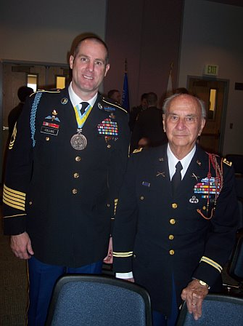

-------Original Message-------

From: Emile Lacroix
Date: 12/28/2008 3:36:34 PM
To: FAMILY and FRIENDS 505RCT
Subject: 82nd Airborne Div.march 2009

Dear friends,
This short note to inform you that the 27th edition of the march "In the footsteps of the 82nd Airborne Division" is scheduled for Saturday February 14, 2009.
For more information click this website:
Website: http://82ndairbornemarch2009.blogspot.com/ :
This site also shows the pictures of the last February 2008 march
Happy New year to all.

Chers Amis,
Cette courte note pour vous informer que la 27ème édition de la marche "In the footsteps of the 82nd Airborne Division" est programmée pour le Samedi 14 Février 2009.
Pour plus d'informations cliquez sur ce site internet:
Website: http://82ndairbornemarch2009.blogspot.com/ :
Ce site présente aussi les photos de la dernière marche de Février 2008.
Heureuse Année à tous.

Emile Lacroix
Email: emile
Tel: 081/834171

PS:
Website: http://82airborne.blogspot.com/ :photos march 2005.
Website: http://82abn-footsteps2007.blogspot.com/ :photos march 2006.
Website: http://82airbornemarch08.blogspot.com/ : Photos march 2007

4 attachments — Download all attachments
MARCH_2009_MAP_ITINERARY Web.jpg
218K View Download

Invit march English.pdf
286K View Download

Invit march French.pdf
283K View Download

Invit march Nederlands.pdf
283K View Download

